## 6.6 Cash-first approaches

**Definition**

What is a Cash-First approach to food insecurity? Cash-First approaches mean providing people with money, rather than emergency food or in-kind support, making them an effective and dignified form of support to people facing hardship locally. Cash provides people with the flexibility to spend it on their immediate needs, whether that is purchasing the essentials (for example food), getting an MOT for their car, buying school shoes for their child, or paying down debt to get on a more secure financial footing. They can have an immediate impact on people’s lives[1]. 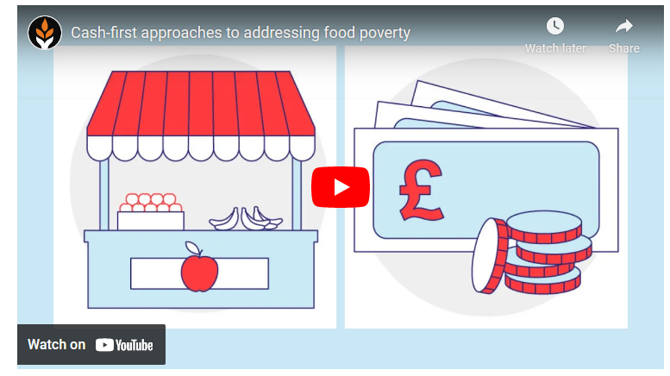There are different ways to embed Cash-First information and resources into partners’ work supporting low income and vulnerable communities across communities. A Cash-First approach focuses on the rationale that maximising income is effective in aiding lower-income residents facing food insecurity.

Sustain has produced this helpful [webinar](https://www.sustainweb.org/events/feb21-cash-first-food-poverty/)[2] to Cash-First approaches:

In a major study of approaches to tackle food vulnerability during the pandemic the authors explain how ‘cash first’ or ‘income-based’ work encompassed a range of responses including schemes designed to refer or support people to access and maximise their entitlements to the social security system (e.g. signposting or advice services) as well as the provision of additional cash support on top of access to basic entitlements through crisis emergency payments (e.g. emergency finance schemes)[3].

For the purpose of this paper we have included reference to literature about the efficacy of voucher schemes, not because they are a form of cash-first grant, rather that these models are often contrasted in the literature reviewed (as seen in the infographic overleaf). Similarly, we refer to grants for food provision, but only in passing as there is a report chapter dedicated to this kind of response elsewhere in this report (see chapter 6.9).

**Food voucher schemes**

Voucher schemes (referred to in this report chapter) provide food vouchers to specific groups of people to enable them to access healthy food. There are both government run schemes like the Healthy Start Vouchers in England (for pregnant women and families with children under 4 years) and the Best Start food scheme in Scotland; and charity funded food voucher schemes like the Alexander Rose Voucher Scheme and research funded projects such as the Fresh Street Voucher Scheme. (See examples later in this chapter).

IFAN’s ‘**Worrying About Money?**’ project aims to reduce the need for charitable food aid by helping people access any existing financial entitlements and advice on income maximisation as a [cash first approach to food insecurity](https://uploads.strikinglycdn.com/files/bf9f4bfb-abfc-4c08-b2e6-a3a04a27a8b4/IFAN%20Infographic%20(1).pdf?id=3713853). Find out more [here](http://www.foodaidnetwork.org.uk/cash-first).

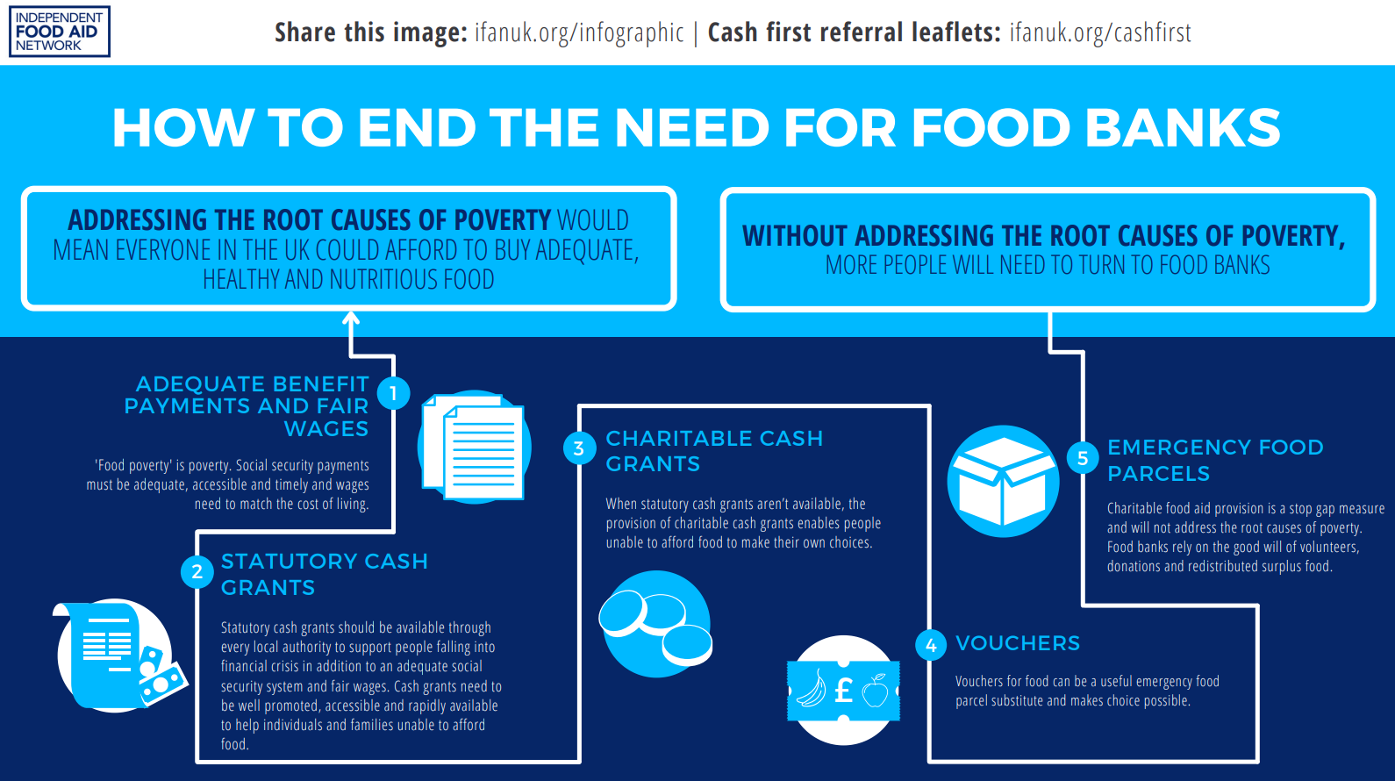[4]

The project seeks to demonstrate why a cash first approach to food insecurity is fundamental to ending the need for charitable food aid.

**Evidence**

**Interventions to address household food insecurity in high-income countries (2018)**

This international review evaluated evidence on interventions intended to reduce household food insecurity in high-income countries. Canada and the USA regularly monitor household food insecurity, while in other countries, such as the UK, it has been the rapid rise of food bank usage that has drawn increased attention to this longstanding, but largely overlooked, problem.

The review supports cash-first approaches above alternatives and concludes that research on social protection interventions suggests both cash transfers and food subsidies (e.g. the US Supplement Nutrition and Assistance Programme in the USA) reduce household food insecurity. In contrast, research on community-level interventions, such as food banks and other food programmes, suggests limited impacts. Although food banks have become a common intervention for food insecurity in high-income countries, evidence suggests their reliance on donations of volunteer time and food make them inevitably limited in the assistance they are able to provide. The stigma people feel using food banks may also make them untenable. Alternatives to, or enhanced, food banks such as community shops or community kitchens, have become common, but evidence also suggests they may be limited in effectiveness if they do not reach people experiencing food insecurity. This review highlights the difficulty of trying to address household food insecurity with community-based food interventions when solutions likely lie upstream in social protection policies.

**Local responses to household food insecurity across the UK during COVID-19 (September 2020 – September 2021). An analysis of experiences from 14 local areas from around the UK and recommendations for future policy and practice appendix (2021)**

This report explores ways in which (14) case study areas in the UK offered or supported income-based responses at the same time as food provision. During September 2020 – September 2021, the use of ‘cash first’ schemes continued and the authors heard examples of local councils and third sector organisations continuing or newly introducing cash first approaches. Three approaches are considered: Support for income maximisation; Cash grants; and Vouchers.

**Income maximisation**

Various activities were being undertaken to support households with income in the form of offering, or signposting people to, advice services. Earlier research[5] by the authors highlighted work to make advice services more accessible by, for example, extending opening hours to include evenings and weekends, and providing services in a number of ways, rather than only face to face. One participant from Derry City and Strabane District Council highlighted this as a positive outcome of the new ways of working during the pandemic:

*“One of the things we found that has really strengthened through the pandemic would be, through the local growth partnerships [and] through community planning, doing a wraparound service. They [community groups] then had a thing of working with the advice services, which maybe a lot of them didn't have that experience before, as we were saying, of signposting things..... That was one of the big positives we found throughout the pandemic, offering that wraparound service for people that needed it.” (Council workshop, Derry City and Strabane)*

Other examples were noted too: local food banks in Herefordshire were starting to offer money advice services; a food aid organisation in Argyll and Bute had paused face-to-face interviews and provided an advice leaflet as an alternative. Although the leaflet was a new response to support income maximisation that they planned to continue they were also hoping to resume the face-to-face service in the future.

It is worth noting that whilst participants highlighted the key role of income maximisation as a response to food insecurity, some also discussed that this may not, alone, be an adequate solution. This is because even with support for income maximisation households are still experiencing poverty, due to the current limitations of social security support or other income. A participant in Glasgow noted that whilst income maximisation had been a key feature of the response earlier in the pandemic, over time, it had been established that this alone was not an adequate solution for everyone:

*“The local Community Food Network was pushing very hard for a cash-first approach to food. There was a lot of partnership work done, bringing in the Citizens Advice Bureaux and the law centres, to do benefits checks with people, but we've, kind of, de-prioritised that work to some stage because what became clear was, in fact, people were on the benefits that they were entitled to. There weren't a lot of people, we found, who weren't getting what they were entitled to, but they still couldn't afford to feed their family, particularly with the recent cuts in Universal Credit. So, we found that actually this idea of maximising benefits of people in food need wasn't the gold or the silver bullet it had been thought it would be, because many, many people were already maximised but still living in poverty.” (Partnership workshop, Glasgow)*

**Cash grants**

In England, local welfare assistance schemes which are administered (designed and implemented) at a local authority level, may provide discretionary grants or support with basic needs, such as food. In the authors’ previous research they learned of changes made to local welfare assistance schemes in response to the pandemic[6]. For example, Leeds Council relaxed their eligibility criteria for their assistance scheme. In January 2021, the Argyll and Bute Community Food Forum, a partnership between the Council, advice agencies, local food providers and a local energy charity, established a ‘flexible food fund’, providing discretionary cash grants[7]. The fund was based on the model implemented by Moray Council and is funded by Argyll and Bute Council:

*“The subsequent programme entitled the Flexible Food Fund Project has been incredibly successful. At our last count we had achieved a client gain of over £800,000 since its beginning in January 2021 and we are going to do everything in our power to continue this vital work beyond March 22 when the present funding runs out.” (Partnership workshop, email submission, Argyll and Bute)*

The fund was promoted in several ways including roadshows, leaflets and social media campaigns[8]. Partnership working was highlighted as a key factor of the initiative.

In March 2021 Cardiff Council launched a new discretionary fund, ‘Together for Cardiff’ to provide emergency grants[9]. Initially this was funded through both Council funding and public donations. From September 2021 it was funded through the Welsh Government’s ‘Food poverty and food insecurity grant scheme’[10]. The fund was made available to individuals and families experiencing severe hardship to provide support with expenses such as paying for essentials like gas and electric, for an essential repair to a cooker or washing machine, for essential furniture or equipment to address digital deprivation. In this respect, the discretionary scheme by Cardiff Council differed to that of Moray and Argyll and Bute. Applicants to the fund are also supported by Cardiff Council's Money Advice team[11].

These practical examples of a ‘cash first approach’, both support for income maximisation and discretionary cash grants were underpinned by a general consensus across the study’s research workshops that ‘cash based’ interventions are the most appropriate because they were seen to provide recipients with choice and dignity. However, similar to earlier findings from these authors, it was acknowledged that there is no ‘one size fits’ all solution with some noting the need for tailoring depending on particular circumstances, for example in rural areas where the cost of living is more expensive or when, despite maximised income, households still experience poverty due to the inadequacy of the welfare support they receive.

**Vouchers**

The authors’ earlier research highlighted that some organisations were providing vouchers for people to use in supermarkets, local shops or for fuel over March to August 2020. This was sometimes existing organisations providing vouchers in addition to food parcels, or as an alternative to their usual provision that was paused, such as to families that would ordinarily attend holiday clubs. In comparison to food parcels, vouchers are seen to allow recipients to have more choice[12]. Some organisations were offering vouchers as an alternative to direct food aid as well whilst some provided vouchers for the larger supermarkets and others for local shops, including smaller retailers such as butchers or fruit and veg shops. Two of the food aid providers that were based in more rural areas described that the vouchers were provided for local shops, with the support of those shops. Referring to the approach the participant said:

*“We put quite a bit of it (funding) into food vouchers, approached all the local stores, none of the multi-nationals, but local stores and asked them to participate in it. That was very successful.”* (Charitable food aid workshop, Derry City and Strabane)

In Herefordshire some food aid providers had started to provide vouchers for local shops. Independent food banks in Shropshire received grants from the Council to purchase vouchers to distribute to households. Where these locally focussed schemes had been introduced this was considered to have the dual benefit of also supporting local businesses:

*“Across South Shropshire and Herefordshire, some of them have fundraised and used their funding to buy vouchers for the local shops. It's also helping local businesses stay afloat as well. So, it's a win-win both sides.”* (Partnership workshop, Herefordshire)

Some organisations provided cash or vouchers for people to link in with other forms of food aid provision e.g. a housing organisation in West Berkshire that was a referral agent for food banks, provided vouchers for community larders. A supported accommodation provider provided cash to residents for the purpose of them attending a "pay what you can" meal service. They also provided support for people to attend the meal. In Belfast, where the provision of vouchers was a relatively new practice participants reported this had been well received and often preferred to food aid:

*“What feedback we were getting is that the voucher scheme was much more preferable to them for reasons of dignity and choice and lots of other things. It's something we in Belfast haven't really dabbled in that much just through some community partners who chose that route to go when we funded them.”* (Council workshop, Belfast)

**Rose Vouchers for Fruit and Veg (F&V) Final Evaluation Report. 2017**

This Project helps families on low incomes to buy fresh F&V and supports them to give their children the healthiest possible start and to promote healthy eating. Eligible households receives £3 a week for each child; or £6 if the child under 1yrs old. The distribution of the vouchers takes a community-based approach and are based in children centres who recruit participants. The vouchers are redeemable only at local market fresh F&V traders. Some participants described drifting in and out of eligibility for the vouchers. Impacts reported in the evaluation included:

* 89% of adults and 94% of children are eating more fresh fruit and 90% of adults and 95% of children are eating more fresh vegetables. The variety of F&V. that families are buying is also increased as families are able to widen the range of fresh produce they buy
* 74% of adults and 83% of children have been eating less sweets and savoury snacks
* Rose Vouchers helped overcome perceived risk when buying new types of fruit and veg
* For some families on very low incomes the financial support that the Rose Vouchers provide is absolutely vital. Budgets fluctuate and at times for some families Rose Vouchers make the difference between being able to feed their family and not
* 70% of families say they are more thoughtful about their food shop
* 92% of families say they are feeling healthier
* 95% of families are feeling happier, saying they have been getting out more, socialising and feeling less stressed financially (emotional wellbeing gains)
* % of participants say they shop more at the market
* 77% of families say they are visiting the Children's Centre more.

*"The Rose Vouchers have really impacted positively in my life. I was lonely when I had my baby and didn't have much money, but when I started coming to the Children's Centre, I met friends and the Rose Vouchers helped me financially" (*Participant from Jubilee Children’s Centre)

*“I use them (the vouchers) with pride – they don’t feel like a benefit”*

The **Fresh Street Vouchers** scheme provides a food voucher for only fruit and vegetables with healthy diet recipes and an information pack. It is an area or place-based scheme with geographically defined streets or areas of high economic deprivation and low F&V consumption and access is open to every household in that area irrespective of composition and individuals’ economic status or income. Each household receive £5 a week. Households are encouraged to share vouchers and vouchers are redeemable in only local fresh F&V shops / market stalls (not supermarket) or locally produced F&V supplied bag by Regather cooperative. While placed based vouchers have greatest impact because of local stakeholders and community buy-in, it may exclude potential benefactors who may be living outside the defined geographical area.

In both examples the voucher schemes provide access to only fruits and vegetables to the recipients and in low-income families and areas where access to fruits and vegetables is limited.

**Can food vouchers improve nutrition and reduce health inequalities in low-income mothers and young children: a multi-method evaluation of the experiences of beneficiaries and practitioners of the Healthy Start programme in England. (2014)**

The results of this study found that women reported that Healthy Start vouchers increased the quantity and range of fruit and vegetables they used and improved the quality of family diets, and established good habits for the future. Conclusions: ‘Our evaluation of the Healthy Start programme in England suggests that a food subsidy programme can provide an important nutritional safety net and potentially improve nutrition for pregnant women and young children living on low incomes. Factors that could compromise this impact include erosion of voucher value relative to the rising cost of food, lack of access to registered retailers and barriers to registering for the programme. Addressing these issues could inform the design and implementation of food subsidy programmes in high income countries.’

**Is Scotland's 'cash first' approach beginning to tackle hunger? (December 2021)**

In spring 2021 when the Trussell Trust released its annual [figures](https://www.trusselltrust.org/news-and-blog/latest-stats/end-year-stats/) for the number of emergency food parcels it had given to hungry people, one thing stood out. The statistics going back to 2014/15 showed that in every region and country of the UK the figures had risen year on year – with one exception. In Scotland, in 2021, there had been a fall. Then, on 24 November 2021, the Trust published more recent statistics, up to September and the trend had continued. As the Trust’s own data [briefing](https://www.trusselltrust.org/wp-content/uploads/sites/2/2021/11/Trussell-Trust-Mid-Year-stats-data-briefing-April-to-September-2021-1.pdf) says: “Data from food banks in our network in Scotland does however remain an outlier in terms of being the only area of the UK to experience a significant (25 per cent) decrease since the same period in 2019. Different policy interventions in Scotland to boost the income of people in receipt of social security may have impacted on the levels of need for food banks in this period.” One of the biggest of these policy interventions has been the [Scottish Child Payment](https://www.gov.scot/news/new-scottish-child-payment-starts-today/) (SCP), introduced in February 2021 this year, which currently pays £10 a week per child under the age of six, to support low income families. Then Nicola Sturgeon [announced](https://www.gov.scot/news/doubling-the-scottish-child-payment/) that the SCP would double that figure to £20 per week per child from April 2022, and be rolled out to children under the age of 16 by the end of 2022. In 2018 the Scottish Government also introduced Best Start Grants for babies and children in low income families[13]. And in Scotland, people who receive Carer’s Allowance can now get a [Carer’s Allowance Supplement,](https://www.mygov.scot/carers-allowance-supplement) an extra payment twice a year. In these and [other ways](https://cpag.org.uk/scotland/welfare-rights/scottish-benefits/payments-children), the Scottish Government has been making a real effort, within its devolved financial and political powers, to put extra money into the pockets of people on low incomes, and particularly investing in babies and children. The Trussell Trust says:

*“Significant evidence exists to show that increasing the value of benefits reduces overall levels of need for food banks. Statistical modelling carried out as part of the*State of Hunger*(2021) research found that an increase of £1 in the value of all main income replacement benefits was associated with a decrease of 2.6 per cent in the number of parcels given out in a typical local authority.”*

It is early days, but this ‘cash first’ approach to poverty by the Scottish Government seems to be working to reduce the need for emergency food aid.

*“And it completely undermines the disrespectful argument that giving people more money is not the answer to poverty. Everybody should have the dignity of an income which enables them to buy their own food, and the statistics from Scotland suggest that the way to achieve that is really not complicated at all.”*

**IFAN Worrying about Money Cash Referral Leaflet evaluation (2021)**

The evaluation[14] sought to understand how the ‘Worrying About Money?’ leaflet was being used in different local authority areas and capture any emerging impact related to its use. The research explored participants’ experiences of using the leaflet including any benefits or difficulties they encountered. The research also asked how the leaflet could be improved. Findings:

* Overall, the leaflet has been viewed very positively by participants. It has been recognised as a useful tool which can help support income maximisation and poverty reduction work at a service, organisational and local authority level. This has been demonstrated by the range of people from local authorities, NHS and third sector organisations who have been involved in using and disseminating the leaflet to date.
* The leaflet is being used in a range of ways which has been dictated both by the contact and relationships services have with individuals experiencing financial difficulties, as well as COVID-19 restrictions.
* The main impact reported by participants is that the leaflet has helped raise awareness amongst staff, volunteers and people experiencing financial challenges, which organisations can provide financial support and how they can be accessed.
* Staff and volunteers also reported that the leaflet had given them confidence to discuss money with people experiencing financial challenges and signpost or refer them to staff.
* While it has been challenging to capture the impact the leaflet has had on individuals experiencing financial difficulties, participants were able to give examples of incomes of those experiencing financial hardship being increased as a result of referrals.
* Participants’ positive experience of the ‘Worrying About Money?’ leaflet has been illustrated in their support for the leaflet being rolled out across Scotland. It was felt that the leaflet was a practical tool that could complement existing resources and approaches to poverty reduction and income maximisation across Scotland.
* For the leaflet to be most beneficial, time and resource need to be committed to tailor the leaflet to the local context, disseminate the leaflet and raise awareness of its purpose.
* Where possible, training should be provided for those wishing to use the leaflet to generate conversations about money to ensure that this is done sensitively.

**Outcomes (Cash-First approaches)**

The following sources were used to derive the list of outcomes that can be associated with **cash-first approaches**.

1. Local responses to household food insecurity across the UK during COVID-19 (September 2020 – September 2021). An analysis of experiences from 14 local areas from around the UK and recommendations for future policy and practice appendix (2021)
2. Interventions to address household food insecurity in high-income countries (2018)
3. IFAN Worrying about Money Cash Referral Leaflet evaluation (2021)
4. Sustain: [Cash-first approaches to addressing food poverty](https://www.sustainweb.org/events/feb21-cash-first-food-poverty/) (2022)
5. Trussell Trust data briefing on mid-year statistics relating to use of food banks: April 2021 –September 2021
6. Trussell Trust, [Cash first literature review](https://www.trusselltrust.org/wp-content/uploads/sites/2/2022/11/Cash-first-literature-review.pdf) (2022)
7. [An evaluation of the Leeds City Council Cash Grant Pilot Programme (](https://www.trusselltrust.org/wp-content/uploads/sites/2/2022/11/Vantage-Point-Research-Leeds-Cash-First-evaluation.pdf)2022)
8. [Five lessons – Learnings from Leeds Cash first evaluation](https://www.trusselltrust.org/wp-content/uploads/sites/2/2022/11/Trussell-Trust-response-to-Leeds-Cash-First-pilot.pdf) (2022)

**Outcomes for individuals**

* More dignity compared to alternatives
* More choice compared to alternatives
* More flexibility for households to address their most pressing financial issues
* Greater confidence amongst staff and volunteers to discuss money with people experiencing financial challenges and signpost or refer them to staff
* Increased incomes for those experiencing financial hardship
* Healthier behaviours (and with more income, life expectancy[15])

**Outcomes for organisations**

* Support income maximisation work by organisations
* Support food insecurity and poverty reduction work by organisations
* Raised awareness amongst staff, volunteers and people experiencing financial challenges which organisations can provide financial support and how they can be accessed
* Tools (e.g. cash-first leaflet) easy to replicate and roll out in different places affordably

**Outcomes for communities / system**

* Injecting funds into the local economy
* Referral pathways into support are strengthened

**Outcomes (Food Vouchers)**

The following sources were used to derive the list of outcomes that can be associated with **food voucher schemes**.

1. Fresh street: the development and feasibility of a place-based, subsidy for fresh fruit and vegetables (2021) and ‘Results FRESH Street:  A place & household approach to fruit and veg consumption’ (2021)
2. Is the Healthy Start scheme associated with increased food expenditure in low-income families with young children in the United Kingdom? (2021)
3. Can food vouchers improve nutrition and reduce health inequalities in low-income mothers and young children: a multi-method evaluation of the experiences of beneficiaries and practitioners of the Healthy Start programme in England. BMC public health (2014)
4. Rose Vouchers for Fruit and Veg- An evaluation report (2014)
5. Rose Vouchers for fruit and veg. Lambeth project final evaluation (2017)
6. 'West Berkshire Case Study, Mapping local responses: March to August 2020. (2021)

**Outcomes associated with the food voucher schemes referenced in this chapter**

Credit for analysis below: Dr Megan Blake, University of Sheffield (2022)

**Access to food/amount of food:** The voucher scheme provide access to only fruits and vegetables to the recipients and in low-income families and areas where access to fruits and vegetables is limited.

**Outcomes for individuals**

* **Improves food and nutrition security**
* **Behaviour changes and healthy eating outcomes**
* **Improves Wellbeing** **Improves household financial wellbeing**

**Outcomes for communities**

* **Community resilience and social infrastructure.** Buying from community markets and stalls increase social cohesion in neighbourhood and provides meeting place for diverse community members for connections and conversations. Place-based voucher schemes have the potential to increase social interaction.
* **Investments in local economy.** Vouchers are mostly redeemed at the local fruits and vegetable markets/stalls - increasing customers for participating stalls, co-operatives and FV producers and increase spending in local market and have the potential to increase footfall in local markets.
* **Connecting with community services /strengthening communities**. Place-based voucher scheme is likely to received greater level of support from local stakeholders and leaders and therefore have maximum impact. And the Rose VS are delivered in partnership with existing local organisations and existing activities focused on health and wellbeing to support families in their local area therefore increase community resilience and social interactions.

**Examples**

**The ‘Worrying About Money?’ Project** has seen cash first referral leaflets co-designed as straightforward resources both for people facing money worries and support workers. The step-by-step guides identify which local agencies are best placed to help people maximise income and access any existing financial entitlements and their design is based on learning from Scotland's [A Menu for Change](https://amenuforchange.wordpress.com/) project. Since June 2020, IFAN has collaborated with local authority teams, advice providers, food aid organisations and other local stakeholders to co-produce cash first referral leaflets for over 90 local authorities in Scotland, England and Wales.

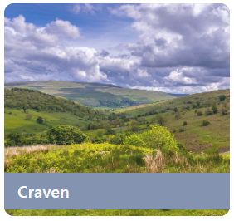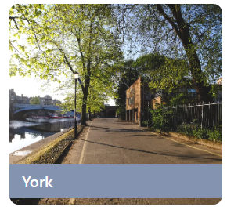

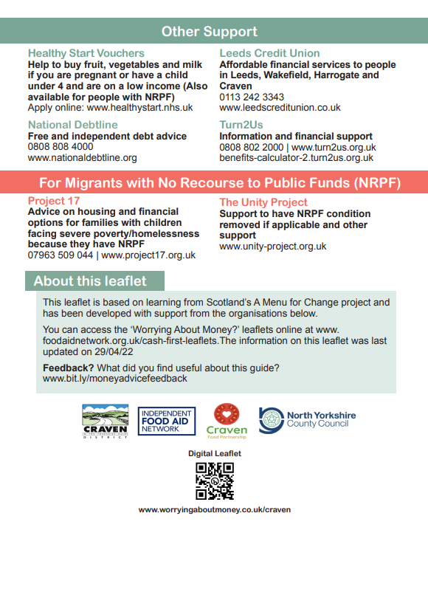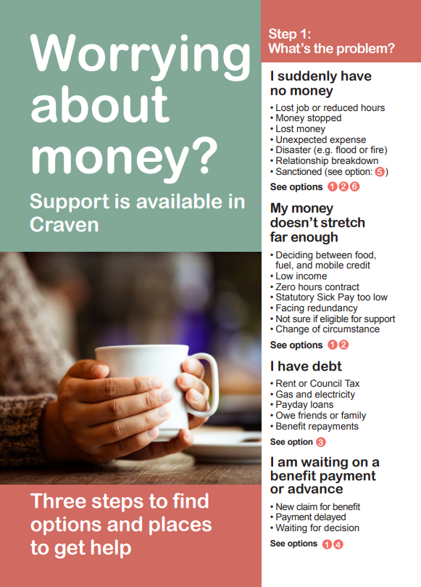York and Craven have produced leaflets for example.

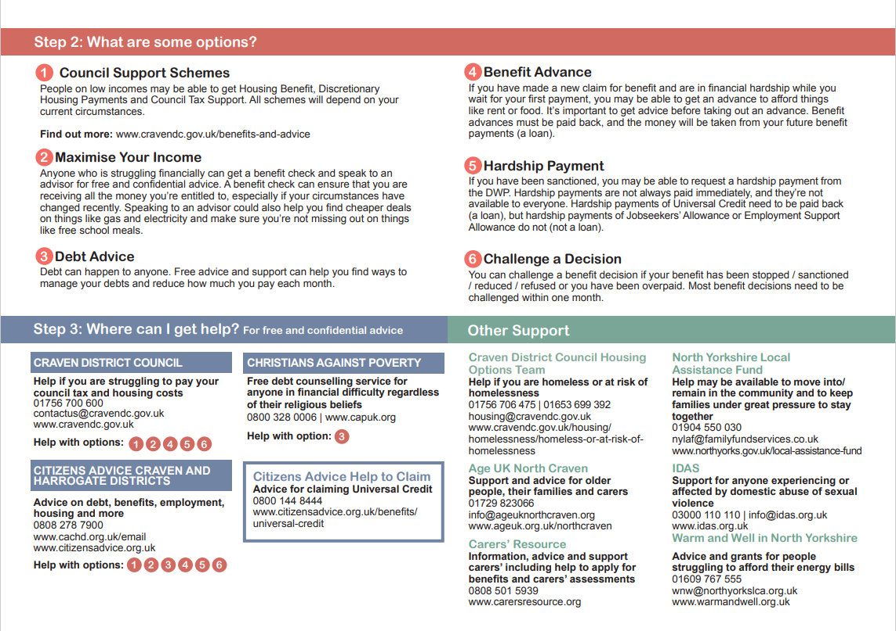

IFAN publishes the leaflets online, helps to disseminate printed copies as widely as possible, and produces poster, translated and interactive versions. Resources to enable training sessions linked to the leaflet are also available on request. IFAN also works with partner organisations to run virtual launch events and to support Money Counts training sessions.  **If any reader is interested in co-producing a 'Worrying About Money?' leaflet for their local area please contact IFAN at admin@foodaidnetwork.org.uk.**[Cash First Leaflets - Independent Food Aid Network UK](https://www.foodaidnetwork.org.uk/cash-first-leaflets)

**Shropshire Food Poverty**[16] is just one example of an area that has produced these leaflets as their work has found that t**he main driving factors behind food insecurity in the UK and Shropshire are insecure and insufficient income. They also assert that emergency food aid and food parcels are sticking plasters and “they don't let us address the root causes of food insecurity and they are not the most dignified way to support people.” The leaflets are** a straightforward, step by step guide for anyone facing financial crisis (and those supporting them) to quickly see the local cash first support and advice which is best placed to help. A tool for individuals, but also a resource for frontline staff and volunteers to help them approach conversations around money with the people they support. “We know that both individuals in crisis, and the frontline staff supporting them, can find support systems complex and difficult to navigate so our hope is that this project will help to reduce barriers to existing financial entitlements and the need for charitable food aid by enabling people to access more dignified, cash first support.”

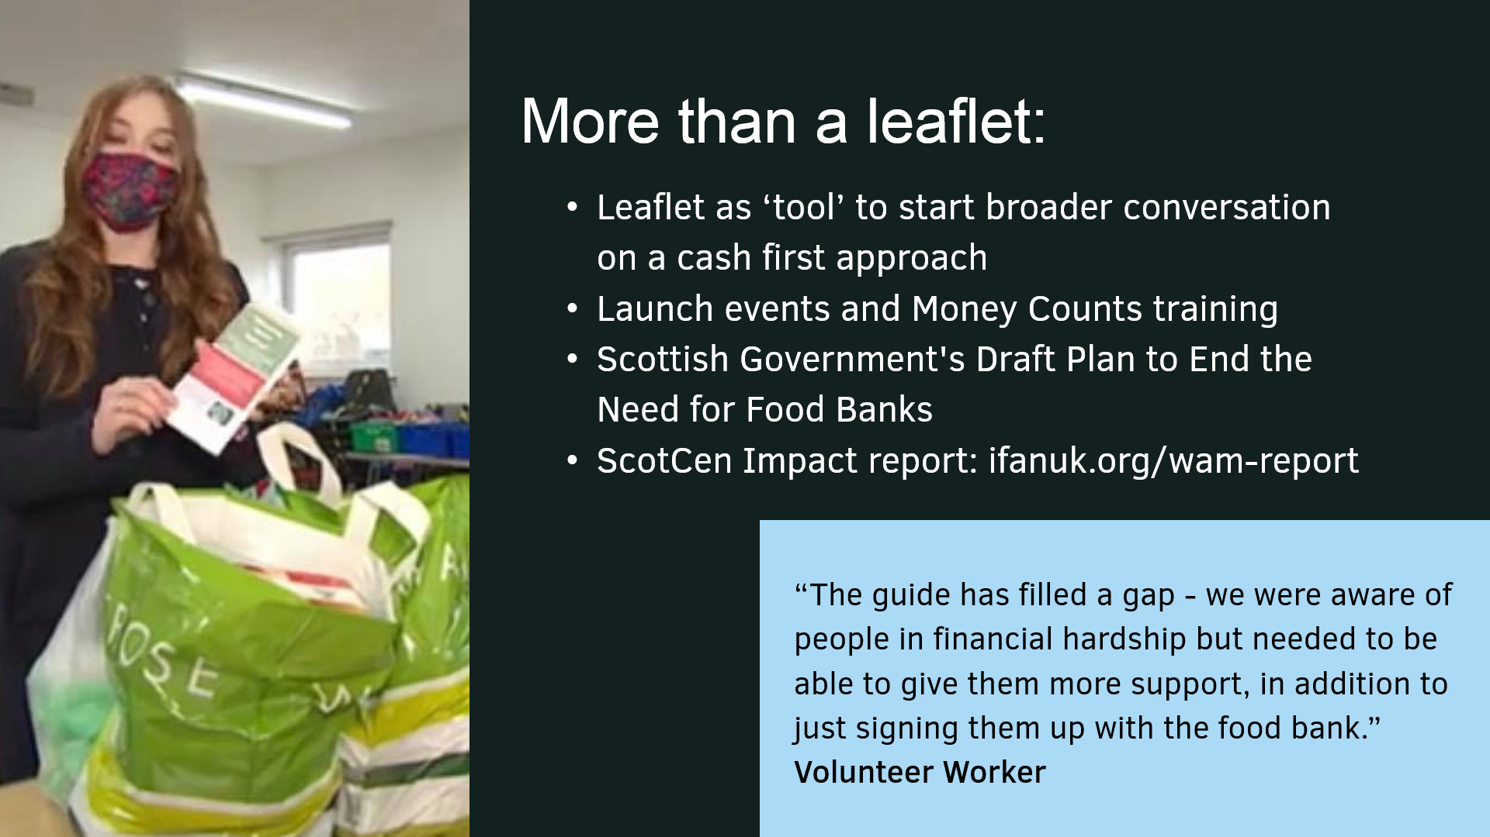

**Cornwall** is another area that has produced the ‘Worrying About Money’ leaflet in partnership with the IFAN, the Trussell Trust and Transformation Cornwall (a charity strengthening faith based social action) and Cornwall Council. By December 2021:

* Over 15,000 Cornwall 'Worrying About Money?' leaflets had been printed and distributed to frontline organisations all over Cornwall.
* Numerous organisations and frontline workers attended a virtual launch event to promote the leaflet and discuss how it could be used.
* By adapting a training resource linked to the leaflet devised by the Highland ‘Worrying About Money? leaflet stakeholder group, the partners co-created a 1-hour online training session alongside [Citizens Advice Cornwall](http://www.citizensadvicecornwall.org.uk/) and had trained 75 frontline workers based in Family Hubs across the county with plans to extend this training further to other frontline council workers.

*“That’s 75 more people resourced and equipped to facilitate informed signposting to advice and support to maximise income and access existing financial entitlements.”*

A focus group with frontline organisations across Cornwall was conducted to hear how they access financial support for the people that turn to them, including their experience of the local welfare assistance from Cornwall Council who have been receptive to recommendations made.

The partners were developing this work further to see how they could better amplify the lived experience of those who have struggled against poverty in Cornwall in shaping the support they receive.

Sustain has usefully collated examples from local authorities about how they have utilised a cash first principle during the Covid-19 crisis. A small selection feature here.

**London Borough of Barking and Dagenham: A ‘cash first’ approach to hardship grants[17]**

The pandemic and the cost of living resulted in the council recognising the importance of getting hardship funds to struggling households as quickly and effectively as possible. In response, a ‘cash-first’ approach to grant provision was adopted which involved the prioritisation of cash grants over in-kind support such as food parcels or shopping vouchers. The council has found that prioritising cash grants over support such as food parcels can offer more dignity, choice and flexibility for households to address their most pressing financial issues, as well as ultimately delivering greater beneficial impacts both for struggling households as well as injecting funds into the local economy.

During the pandemic and when the severity of COVID-19 related hardship quickly emerged, the council designed and implemented its own new local welfare fund from scratch in the space of two weeks. Cash payments were central to this scheme and funds were paid over several weekly instalments. Previously, sending cash payments through internal financial process was a challenging process and disbursing funds was time-consuming and complex, this meant it could mean days before customers received much needed funds. Yet, through its adoption of a new innovative cash payment solution called Cash Perks[18], the council can now send payments instantly to its beneficiaries. The council first piloted Cash Perks just for those without bank accounts. But its success, in both cutting staff time and costs taken to process payments and reducing the time taken for recipients to receive funds from days to minutes, has seen it become their default payment method for various discretionary fund schemes, including the Household Support Fund.

LBBD staff have now disbursed almost £1 million through the facility that enables staff to either individually or bulk upload payments between £10 and £500 that are sent via SMS texts. The funds are instantly available for the client collection locally at over 17,000 ATMs nationwide using the credentials within the messages, that has seen 97 per cent of payments collected on time.

**Greater Manchester Poverty Action**

In its 2020 Briefing Paper, ‘Cash-First - Responding to the needs of low income residents through the provision of local welfare support[19]’ the importance of taking a ‘Cash- First’ approach to local welfare provision is emphasised. It outlines the benefits of this approach and suggests that local welfare assistance schemes would be a suitable route to supporting people in this way.

The paper argues that the best way of giving low income residents maximum dignity, choice and control when accessing local welfare support is via a ‘Cash-First’ approach which prioritises providing support to people who are facing financial hardship in the form of cash grants and loans rather than vouchers, food aid or goods (in-kind support).

It states:

‘It is important that localities do not allow misplaced negative perceptions to act as a barrier to providing people with crucial support. Evidence shows that when extra financial support is provided to low income households in crisis it is used appropriately and in a way that boosts household wellbeing. A ‘cash first’ approach to local welfare would deliver the following benefits:

* Giving people dignity by removing the stigma that often comes with using in-kind support.
* Giving people choice and control by enabling them to use support in a way that works best for them, enabling them to meet the multiple needs that they have. This boosts household wellbeing and has significant benefits in households with dependent children.
* Giving people what they want – cash is the preferred option for most people on low incomes.
* Simplicity and efficiency - Cash payments are the simplest, efficient and cost effective means of providing people with support as cash payments can be made directly into people’s bank accounts. It can be a more efficient approach for local authorities as it removes need for the partnership arrangements that come with in-kind support.
* Increasing take up - Cash payments encourage greater take up of support by households experiencing financial hardship.
* Giving a boost to the local economy by increasing the likelihood of payments being spent with local, independent retailers.
* Preventing people from falling into high interest debt when they face a financial crisis, and therefore preventing them from spiralling deeper into hardship.
* Bolstering wider financial inclusion efforts by linking cash payments to other sources of financial support such as credit unions.
* Enabling funding to be recouped where there is a loans element to cash payments being provided.

**Maximising positive outcomes through local welfare provision: dignity, choice and control**

‘Poverty is the consequence of having insufficient resources to meet one’s needs and people experiencing poverty have multiple needs. Therefore, Greater Manchester Poverty Action believes that responses to poverty should give people maximum choice and control, and that this best done by providing people with cash benefits rather than in-kind support (i.e. vouchers, food aid or 4 household goods).

It is difficult to see how the provision of limited goods or vouchers can meet the broad range of needs that families have, for example clothing, mattresses, sanitary products, crockery, children’s books and toys, cleaning products, travel vouchers, child safety equipment, birthday presents – all vital to help people create a home and a family life for their children. The principle of paying benefits in cash is generally largely applied through the national social security system, with benefits paid in cash rather than in the form of vouchers. However, local welfare schemes often run counter to this principle.

Many local welfare assistance schemes across England offer a limited and narrow range of in-kind support such as vouchers, specific goods and referrals to crisis support such as foodbanks. There can be significant stigma attached to making use of vouchers or visiting a foodbank.

The LGA advises that ‘providing direct cash payments through hardship schemes will maximise flexibility and choice’. It is also the preferred option of people experiencing poverty.

Recent research by Child Poverty Action Group (CPAG) into the provision of Free School Meals during school holidays found that most families preferred to receive support through direct payments to their bank accounts, as this method allowed flexibility, dignity, safety and convenience.

**Other benefits of a ‘cash first’ approach**

Providing people with cash gives them greater dignity, choice and control, but it also has other benefits:

* Vouchers provided to people experiencing poverty, for example to meet food needs, are often only available for use at a limited number of supermarkets. By providing cash, people can use money at the retailer that best meets their needs and increases the likelihood of money being spent with local, independent retailers, thus retaining money in the local economy.
* Cash payments are a simple and effective means of getting support to people in need as quickly as possible. As payments are made direct to the person in need, partnership arrangements with external VCSE, private or public sector agencies are not needed. Some councils have reported that the move from direct cash payments to the provision of specific goods or vouchers was discouraging some people from applying for support – not because of a reduction in basic need, but because families often need help managing a temporary cash flow problem.
* Cash payments can prevent people from needing to borrow money from high interest (legal or illegal) lenders. By preventing people entering a debt crisis through cash payments, local authorities can help reduce the likelihood of people relying on local welfare provision and other local support services in the future.
* A shift to greater cash provision in Greater Manchester could involve the introduction of no or low interest loans alongside grants. This would mean that some of the money spent through local welfare assistance schemes could be recouped and reinvested back into providing support. A ‘cash first’ approach could support a wider financial inclusion agenda, linking payments to access to credit union accounts and other financial support services.

**Edinburgh**

Edinburgh Community Food[20] has shared learning about its Cash-First approaches at a November 2022 conference. Take 5 Access is a partnership supporting Edinburgh's Community Cafés post COVID with objectives to support individual with healthier food to eat socially, healthier food to take home, resources and skills to use healthier food, have access to Cash-First support and resources and connecting communities through the Community Café network. It aims to reduce the risk of food insecurity, increase opportunities for healthier food; and enhance the provision of skills, resources and supported signposting. Community cafes received fresh produce and recipes for three months, free meals for children, fuel payments for those in need, fruit/meal kits to take home, online cooking groups, Ask and Act: CHAI/GIC, tablets and training for staff/volunteers

*Impact:* Café staff: ‘The [Ask & Act] stalls were a huge hit and we are arranging for more. We have thoroughly enjoyed taking part in this project. It has engaged us with our community in a fun, caring, supportive and educational way. The elderly in our cafe seemed most to appreciate this. We have a lot of people come to eat so they don't have to, can't or don't know how to cook at home.’ REHIS Training: ‘Excellent…..good mix of facts, visuals, discussion & real life examples / I will be able to introduce what I’ve learned over the last two days in our kitchen.’ Eat Well Age Well training: ‘It has given me the means to enter into the conversation with customers and to access ways to help.’

*Challenges*

* Understanding ECF has a role to play around cash first when capacity already pushed
* ECF must support and enable cafes and communities to improve health and wellbeing
* Complexity of benefits/welfare systems
* Benefits training from CHAI: highlighted importance of expert partnerships
* Catering staff/volunteer capacity
* Adapting project delivery to assist café capacity

Legacy

* ECF staff: increased understanding and embedding in delivery e.g. Best Start/Pension Credits/£25 Scottish Child Payment uplift
* ECF developed partnerships, have become a bigger part of a wider solution
* ECF focused on impact of policy on our communities, voice for community to government
* Involved in End Hunger Edinburgh, Ending the Need for Food Banks, members of Poverty Alliance

Other Cash-First approaches: VOCAL Carers’ Support –Rounds 1&2 –2022-2023Food, equipment, fuel payments; IFAN/Worrying About Money? Leaflet distribution (English/Ukrainian) Discover! / Ukrainian response / Crisis food deliveries / Development work; Enliven -2022Community meal + food, equipment, CHAI/HES Ask & Act points; Coorie in –2023Community café community meals, food, Coorie In packs, fuel payments, CHAI/HES Ask & Act points; Implementation of Scot Gov Cost of Living -Campaign Resources; Best Start –ongoing; Added-value tailored boxes, home delivered o£18 fresh produce pcm+ extras; IFAN, signposting and health promotion content.

**Leeds Cash-First Pilot and Evaluation**

Laura Chalmers, Trussell Trust Area Manager for Yorkshire and Humber, reported in December 2022 that after two years of collaboration the Trussell Trust held a launch event of its cash first pilot with Leeds City Council in late 2022 with 245 attendees (including 56 Councillors) and 8 people from DWP. This pilot includes Leeds North and West, Leeds South and East and Wetherby Foodbanks alongside the Trust and Leeds City Council, the latter confirming recently that they have decided to keep the cash-first element of their local welfare scheme long term. Documents about the pilot and a recording of the webinar are found here: [How we’re working with local government - The Trussell Trust](https://www.trusselltrust.org/what-we-do/research-advocacy/working-with-local-government/)

The pilot scheme provided cash grants to people in financial hardship in Leeds, running from 1 October 2021 to 1 April 2022, and distributed £45,450 between 187 grants, supporting 283 individuals rather than emergency food aid (parcels). An external evaluation was commissioned that offered these five learning lessons:

1. Cash grants have an immediate impact on a person’s financial situation and can prevent them from needing to turn to a food bank for support.

2. Cash grants are a more dignified form of support when people face financial hardship - people overwhelmingly prefer receiving a cash grant than an emergency food parcel from a food bank.

3. People use cash to buy the essential items, particularly food, gas, and electricity. This strongly supports existing international and UK evidence that cash transfers do not lead to ‘misuse’.

4. Cash grants can also unlock benefits beyond purchasing the essentials, including paying down debt or reducing the impact of larger one-off costs such as paying for a car’s MOT to be able to get to work. This can be vital in putting people on a financially secure foundation for the long-term.

5. Cash grants should be an option when providing support to people facing financial hardship locally, but alone can only provide short-term respite. They should be situated within a wider local ecosystem of support available to people, alongside a national social security system which provides people with enough income to afford the essentials.

The pilot scheme aimed to impact four areas for grant recipients:

1. To increase their emotional wellbeing
2. To negate the need for further food bank use within 12 months
3. To enable them to be better able to afford the essentials
4. To enable them to be better able to manage their financial situation

The evaluation of the pilot scheme found that the impact of cash grants on recipients was mainly short-term, with a decline after the grant period ended. There were longer-term impacts in some areas. The cost of living crisis and other issues affecting grant recipients such as ill health, benefit problems and debt all restricted the pilot scheme from achieving a longer-term impact.

The underlying causes of need for grant recipients were primarily benefits issues, debt, ill health, and changes in personal circumstances.

Improvements in finances were generally felt for the duration of the grant only, with 91% of grant recipients reporting an improvement in their finances while receiving the cash grant. 78% of grant recipients agreed that their ability to afford the essentials improved during the grant period.

Longer-term impacts of the scheme included the ability to accumulate small amounts of savings, increased confidence in financial management, debt repayment, and purchase of durable household items. The cost of living crisis, other personal issues and the design and delivery of Universal Credit all negatively affected the longer term impact of the scheme.

People supported by the grant commonly received food bank support before and after the grant period. A small percentage needed support from a food bank while receiving the grant. Grant recipients also anticipated that they would continue this use, although nearly all would prefer a cash grant over a food parcel. 94% of grant recipients would prefer a cash grant over a food parcel.

The emotional wellbeing of the grant recipients was generally improved by the cash grant, mainly for the short-term. The cash grant was preferred to using food banks partly because of the negative emotions associated with using food banks. In comparison the cash grant was valued for its flexibility. The cash grant was perceived to provide a more dignified option, which supported individuals’ agency and freedom of choice, compared with receiving support from a food bank. Some grant recipients reported however that they had not experienced any positive change to their emotional wellbeing as a result of receiving a cash grant. The freedom of choice of how to spend the cash grant allowed grant recipients to prioritise spending on their immediate needs. The most frequently bought item was food.

Most people spent their cash grant on food as a priority and then spent any remaining grant on other pressing needs, mainly gas and electricity payments.

People liked to choose what food they bought, based on their families’ preferences and dietary requirements, and they could buy frozen and chilled foods that are not available in a food parcel. Operationally, the vast majority of grant recipients felt that payment was made quickly and easily. Overall satisfaction with the pilot was also strong. Nearly all (97%) grant recipients felt that they did not have to wait a long time after applying to receive confirmation that they were being awarded the grant. 60% of grant recipients had no problems accessing the cash grant from a cash machine. The top issues encountered related to travel to, and issues at the cash machine.

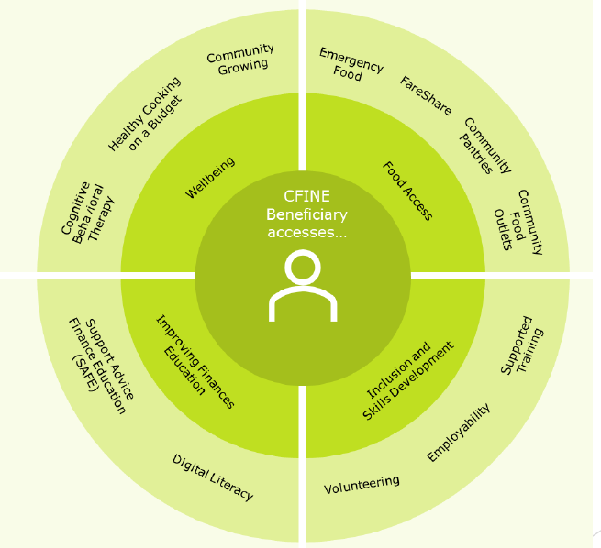**CFINE[21]: Cash-First and wrap-around**

At a Public Health Scotland webinar focused on Cash-First responses, **Community Food Initiatives North East**(CFINE), a charity shared insights about adopting a Cash-First approach based on income maximisation for beneficiaries. They assert that:

* Emergency food does not solve the problem; it creates dependency, erodes dignity, does not change status quo, However, essential if no other way of accessing essential support e.g., food.
* Food is more than often, the “vehicle” to other essential support services available
* ‘Cash first’ as a standalone approach simply does not work. Beneficiaries need access to a range of wrap-around services to tackle underlying issues/causes.
* Poverty is often complex and for this reason, requires holistic and person-centred responses. (see diagram overleaf).

**CFINE’s approach: Income Maximisation example: Support, Advice, Finance, Education**

* Financial capability/inclusion team based ‘on the ground’ at CFINE
* Welfare/benefits support and advice (including supporting benefit applications, appeals, tribunals)
* Budgeting advice
* Wraparound support including accessing additional services e.g., Pantries, Volunteering, Employability, Cooking
* 2021-22 secured £1,586,372 in financial gain for beneficiaries

**CFINE’s approach: Income Maximisation example: Employability & Skills Development**

* Introductory & Warehouse Skills Development Programmes
* Stage 1-4 of Employability Pipeline delivered in-house
* Work experience and training
* Accredited training (e.g., food safety, forklift accreditation)
* Employability support (CV’s, interview prep, job search)
* Cooking on a budget, 1 to 1 SAFE and wraparound support
* 62% success rate of participants gaining employment within 6 months

**Learning**

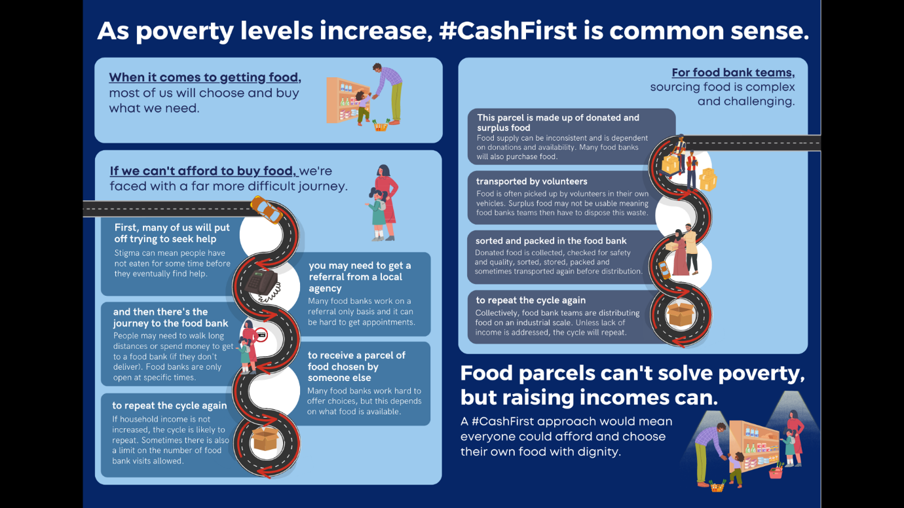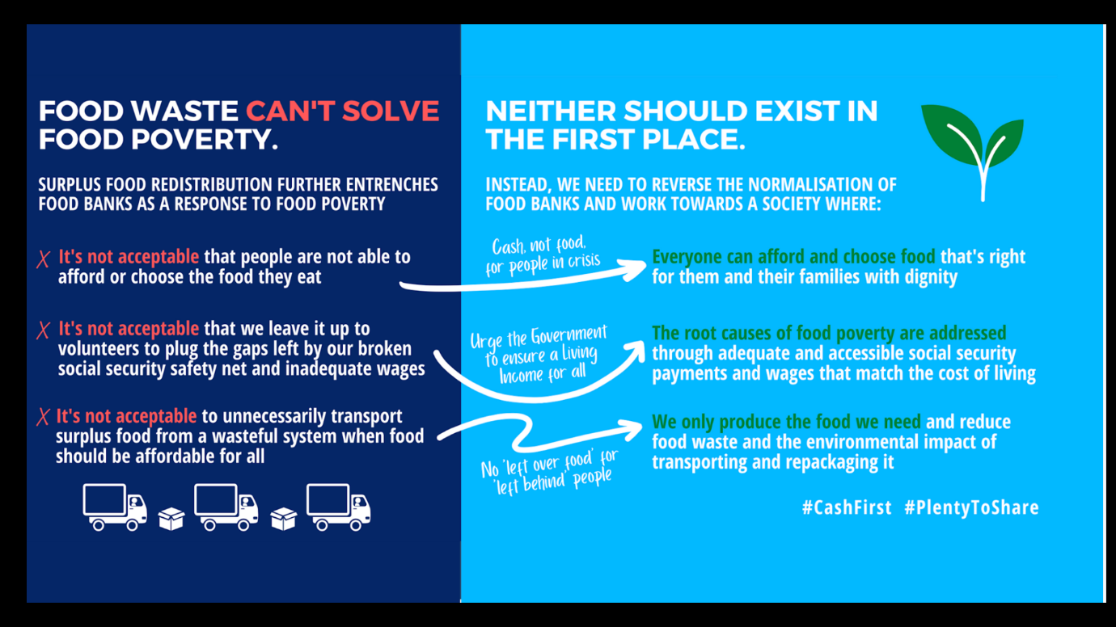Here follows a range of learning slides shared by IFAN at a November 2022 conference about Cash-First approaches

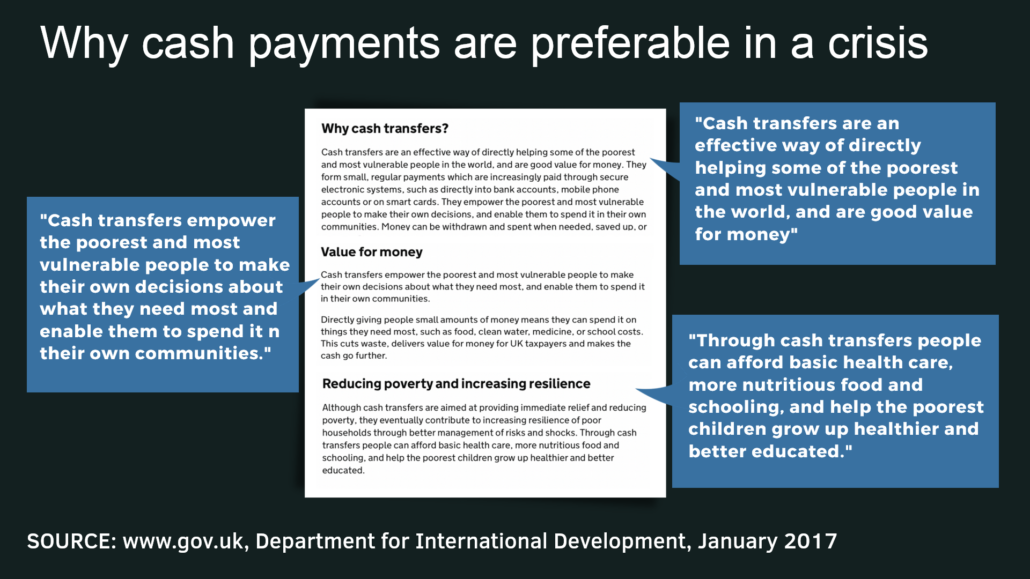

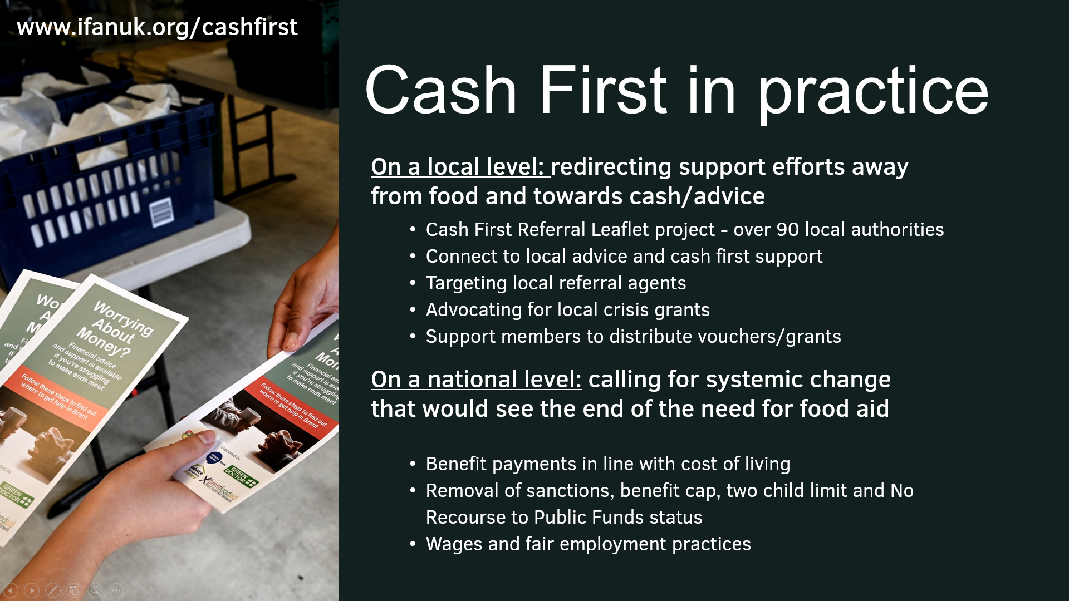

**The case for cash-first approaches?**

IFAN is at the forefront, alongside others such as the Trussell Trust, in calling for a Cash-first approach in the UK to address the causes of food insecurity. IFAN’s vision is of a country without the need for charitable food aid where adequate and nutritious food is affordable to all. IFAN calls for governments and national and local partnerships to prioritise [a cash first approach to food insecurity](https://uploads.strikinglycdn.com/files/bf9f4bfb-abfc-4c08-b2e6-a3a04a27a8b4/IFAN%20Infographic%20(1).pdf) and to work together to address the root causes of food insecurity and poverty.

IFAN is working to promote a cash first approach to food insecurity in a number of ways:

* by advocating for all local authorities to provide adequate, well-promoted and easy accessible cash payments to people in financial crisis
* by advocating for systemic changes that would see social security payments and wages match the cost of living and the root causes of food insecurity and poverty addressed
* by co-developing and circulating [cash first referral leaflets](https://www.foodaidnetwork.org.uk/cash-first-leaflets) across multiple local authorities
* by supporting their member organisations to use shopping cards or vouchers and/or cash grants instead of or alongside food parcels or other food support

Please see these links for further arguments linked to this topic  
[Why Cash First? - Independent Food Aid Network UK](https://www.foodaidnetwork.org.uk/cash-first)

* The case for cash first - moving on from vouchers and food parcels as a response to food insecurity | November 2021 | [READ HERE](https://www.youtube.com/embed/qemz09khuB0)
* Webinar: Cash-first approaches to addressing food poverty | Sustain | February 2021 | [READ HERE](https://www.youtube.com/watch?v=DIQLLJ7fPqs)
* The growing need for charitable food aid and a cash first approach to food insecurity | Isle of Wight Food Waste and Food Poverty Conference | November 2022

**Questions arising**

* How can local authorities address increased financial hardship and food insecurity in an efficient and just way?
* What work are local authorities and others doing to ensure that money gets directly to those who need it the most?
* How can Cash-First responses work most effectively alongside models of wrap-around support?
* Under what conditions would local authorities consider Cash-First rather than alternative forms of support that might unintentionally create dependency?
* Do the examples in this chapter help us visualise further ways in which community cafes could play a part in actively promoting and participating in Cash-First approaches e.g. like the Edinburgh Take 5 Access arrangements?
* To what extent does York and North Yorkshire find the arguments made by the [Greater Manchester Poverty Action](https://www.gmpovertyaction.org/wp-content/uploads/2020/08/GMPA-Briefing-%E2%80%98Cash-first-August-2020.pdf) persuasive regards theirs, and the LGA’s recommended, approach to a cash-first approach for local welfare assistance schemes? Would any change to the existing schemes enhance the positive outcomes for people in hardship feeling dignity, choice and control?

1. [Edinburgh Community Food and the Cash First Approach](https://www.edinburghcommunityfood.org.uk/cash-first#:~:text=Cash%20first%20approaches%20mean%20providing%20people%20with%20money%2C,form%20of%20support%20to%20people%20facing%20hardship%20locally.)
2. [Cash-first approaches to addressing food poverty | Sustain (sustainweb.org)](https://www.sustainweb.org/events/feb21-cash-first-food-poverty/)
3. Local responses to household food insecurity across the UK during COVID-19 (September 2020 – September 2021). An analysis of experiences from 14 local areas from around the UK and recommendations for future policy and practice appendix (2021)
4. [IFAN Infographic (strikinglycdn.com)](https://uploads.strikinglycdn.com/files/bf9f4bfb-abfc-4c08-b2e6-a3a04a27a8b4/IFAN%20Infographic%20(1).pdf?id=3713853)
5. Lambie-Mumford, H., Gordon, K., Loopstra, R. and Shaw, S. (2021) ‘Comparing local responses to household food insecurity during COVID-19 across the UK (March – August 2020), published July 2021, available online http://speri.dept.shef.ac.uk/food-vulnerability-during-covid-19
6. 22 Lambie-Mumford, H., Gordon, K., Loopstra, R. and Shaw, S. (2021) ‘Comparing local responses to household food insecurity during COVID-19 across the UK (March – August 2020), published July 2021, available online http://speri.dept.shef.ac.uk/food-vulnerability-during-covid-19
7. https://www.argyll-bute.gov.uk/forms/flexible-food-fund
8. https://www.foodaidnetwork.org.uk/cash-first-leaflets
9. https://www.cardiffmoneyadvice.co.uk/benefits-and-income/cardiff-discretionary-emergency-fund/
10. https://gov.wales/food-poverty-and-food-insecurity-grant-scheme
11. https://www.cardiffnewsroom.co.uk/releases/c25/26014.html
12. https://uploads.strikinglycdn.com/files/bf9f4bfb-abfc-4c08-b2e6-a3a04a27a8b4/IFAN%20Infographic%20(1).pdf?id=3713853
13. The Pregnancy and Baby Payment gives eligible families £600 on the birth of their first child and £300 on the birth of any subsequent children – not putting a limit on the number of children that can be supported. The Early Learning Payment is £250 for toddlers, and the School Age Payment is £250 to help with the costs when a child starts Primary school. Scottish Social Security Secretary Shirley-Anne Somerville [said](https://www.thenational.scot/news/18228170.scottish-governments-20m-best-start-grant-boost-families/): “For a two-child family, the Best Start Grant package will provide total support of £1900 to £2400 more than they would get under the previous UK system. This shows the direct difference we are making to families across Scotland with our new powers over social security.”
14. ## Methodology: ScotCen conducted 14 semi-structured telephone and video interviews with delivery partners, advice providers and community food aid providers in four local authority areas: Argyll & Bute, Glasgow, Highland and West Lothian. Interviews took place between 11th August and 3rd November 2021. [NatCen Social Research](https://natcen.ac.uk/our-research/research/worrying-about-money-scotland%E2%80%99s-cash-first-referral-leaflet/)

   
15. # [Relationship between income and healthy life expectancy by local authority](https://www.health.org.uk/evidence-hub/money-and-resources/income/relationship-between-income-and-healthy-life-expectancy-by-local-authority), Health Foundation (2021)

   
16. [Cash first solutions to food insecurity | sfpa (shropshirefoodpoverty.org.uk)](https://www.shropshirefoodpoverty.org.uk/cash-first)
17. [London Borough of Barking and Dagenham: A ‘cash first’ approach to hardship grants | Local Government Association](https://www.local.gov.uk/case-studies/london-borough-barking-and-dagenham-cash-first-approach-hardship-grants)
18. [www.cashperks.co.uk](http://www.cashperks.co.uk/)
19. [Cash first approach to welfare provision - Greater Manchester Poverty Action (gmpovertyaction.org)](https://www.gmpovertyaction.org/cash-first-approach/)
20. Cash First Edinburgh and [Cash First (edinburghcommunityfood.org.uk)](https://www.edinburghcommunityfood.org.uk/cash-first)
21. ## CFINE improves health and wellbeing and the environment, tackles poverty and builds resilience through a range of support and services for and with disadvantaged, vulnerable, low-income individuals, families and communities in North East Scotland [Homepage - Cfine](https://www.cfine.org/)

   