## 6.4 Collaborative models

This section focuses on different types of collaborative food model found in the literature, including Local Food Partnerships (LFPs), Food Poverty Alliances (FPAs), food insecurity taskforces and food networks.

**Definitions and characteristics[1]**

Local Food Partnerships (LFPs) are cross-sector bodies that own and drive forward agendas on their local food system. Sub regional partners may also play a part. Local Food Partnerships involve local authorities and other public bodies, working together with third sector, faith groups, business, and academic organisations with the goals of promoting public health and wellbeing; fostering community connection and resilience; building prosperous and diverse local food economies; and helping to tackle the sustainability issues of waste and the climate and nature emergency. Food Poverty Alliances (FPAs) can take different forms. Some are sub-groups of pre-existing local food partnerships whilst others have recently emerged from coordinating responses to Covid-19. Alliances share responsibility for their sustainability, funding, reaching out to organisations that might be harder to engage and maintaining momentum, even during periods of lower funding. Evaluations of LFPs and FPAs were found in the evidence review, whilst food insecurity alliances or taskforces appear to be a more recent development and nomenclature with fewer published evaluations of their effects to date. The activities delivered by different collaborative models include but are not limited to:

* Supporting food access: - low cost community food retail e.g., social supermarkets, pantries (membership / nominal payment)
* Wrap around support e.g., money advice services, signposting, apps
* Cash based responses e.g., income maximisation, cash grants and vouchers
* Resources for food response
* Direct food provision (to people’s homes and out of home)

Some partnerships may adopt different foci, for example the Blackburn and Darwen Food Power Alliance focused on young people with a specific intention of empowering young people to create local change.[2][3]

**Outcomes**

The outcomes listed below are predominantly drawn from the following sources:

1. Local responses to household food insecurity across the UK during COVID-19 (September 2020 to September 2021). An analysis of experiences from 14 local areas from around the UK and recommendations for future policy and practice.
2. Food Power, Final Evaluation Report (2021)
3. Working in collaboration - Leeds Food Insecurity Taskforce (2022)
4. Food Insecurity: Understanding local delivery, impact and innovation in the North East Riding (2021)
5. The Value of Local Food Partnerships: UK Sustainable Food Places Evaluation Report (2022)
6. Household Food Security in the UK: A Review of Food Aid Final Report (2014)
7. Food Poverty Alliances (2019)
8. Ways to care: Forms and possibilities of compassion within UK food banks (2021)
9. [East Riding Food Poverty Alliance End of project feedback for lottery](https://www.erfpa.org.uk/erfpa-end-of-project-feedback-for-lottery-final/) (2021)
10. Seeking Justice. How to understand and end food poverty in York (2019)

**Outcomes for communities / localities as a result of collaborative models**

* Systems leadership on food issues
* Improved levels of partnership working, co-ordination and collaboration
* Conditions are created to find shared visions for change / common purpose
* Emergence of a strategic direction and practical action / solutions
* Creation of efficiencies and reduced duplication of effort in the same locality
* Improved local food systems
* The assets of multiple / cross-sector partners / organisations are leveraged
* Increased skills and capacity compared to food aid / support models working in isolation
* Development of food poverty action plans
* Creation of an agenda for ‘good food’
* Can help tackle rural challenges which can be disproportionate to urban contexts
* Help organise local provisions in an agile way to meet changing needs
* Shared learning
* Shared resources
* Sharing good practice to improve delivery to meet local needs
* Means to showcase specific interventions
* New partnerships or newly constituted partnerships to meet current need
* Improved monitoring, evaluation and learning of local action in an agreed / consistent way across multiple food aid / support providers in an area
* Better opportunity for demonstrating collective impact to stakeholders / communities
* Raise direct funds and / or re-direct funding to align with agreed priorities
* Approach and action plans influenced / prioritised by / with experts by experience
* Promotion of food citizenship
* Reduced food waste across the network
* Promotion of equality, diversity and inclusion principles meaning that local action can be tailored to meet people with highest / different needs

**Outcomes for individuals**

* Personal development for experts by experience involved in the model
* Increased awareness and understanding of food poverty/insecurity by all involved
* Relief from / reduction in food insecurity
* Empowerment through involvement in designing local action plan
* Skills development – how to co-operate, collaborate and work in partnership
* Accessing new opportunities
* Improved diet / access to nutritional quality of food provision

**Evidence**

**The Value of Local Food Partnerships (2022)**

This evaluation considered 69 Local Food Partnerships that are members of Sustainable Food Places (SFP), a UK programme led by three national sustainable food organisations – the Soil Association, Sustain and Food Matters. The aim of SFP has been to bring about a fundamental change in the food system. SFP has sought to catalyse, inspire, and support multi-sector, local food partnerships to take a strategic and holistic approach to the sustainable food agenda. It concludes there have been four key results emerging as a result of the Local Food Partnership model.

1: In terms of *effectiveness,*LFPs tackle the fragmented and siloed operations of the local food systems. Working across complex and cross-boundary environments, LFPs are a unique type of partnership that help coordinate action on dysfunctions and opportunities for change in local food systems.

2: Regarding *efficiency*, LFPs encourage public, private and third sector agencies to collaborate and share resources. Examples from SFP member areas show how this partnership model provided a powerful way to create efficiencies, eliminate duplication and create innovative solutions.

3: From the standpoint of *engagement*, LFPs are designed to focus action on the interests of people and environment, ahead of the convenience of providers. This requires having mechanisms for consultation and co-production. LFPs are configured to engage lived experiences and to find shared visions for change.

4: Finally, in terms of *equity*, LFPs respond to the moral and legal case for promoting equality, diversity and inclusion through their open networks, outreach, and democratic structure. In embracing multiple voices, LFPs act as collectives working for food system leadership at the local level.

**Further evidence is found here** [Food Governance and Strategy | Sustainable Food Places](https://www.sustainablefoodplaces.org/resources/food_governance_and_strategy/), however, these studies assert that LFPs have created impacts and achievements, and have been able to embed and amplify their work to deliver both local and national food priorities.

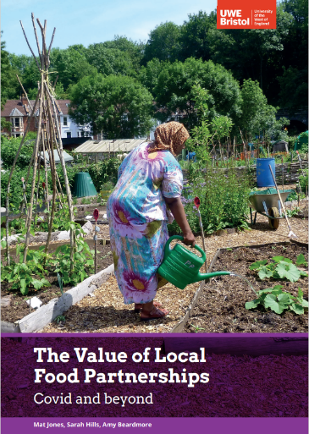

“LFPs have been uniquely placed to provide systems leadership and practical solutions through the strategic direction and support of the UK-wide Sustainable Food Places (SFP) programme, established a decade prior to the pandemic. LFPs have been able to pivot to respond with agility to an extended period of national crisis and have moved forward to offer a coherent framework for the transition of local food system. The four dimensions of 'effectiveness', 'efficiency', 'engagement', and 'equity' highlight the value of LFPs to fill the leadership gap on local food issues[4].”

Furthermore: 'place-based strategies and partnership approaches have potential to create more sustainable food systems and to engage people and organisations shifting towards healthy and sustainable food systems at a local level[5]'. A 2019 NHS publication (The Design, Deliver and Manage), specifically advises creating a local food partnership, adopting a whole systems approach and references Brighton and Hove Food Partnership, Good Food Oxford and the Sugar Smart campaign[6]. A Public Health England report published in 2017[7] also asserts that ‘Strategic partnerships across relevant local council departments (for example, planning, economic development and public health), as well as with external agencies and the local community can add value to interventions’.

In another study[8] (2021) the authors found that LFPs directly raised food aid funding through popular subscription, grant applications and actions to re-direct funding. In localities where they had the greatest influence, LFPs were able to channel public resources and actively organise provisions to meet the food assistance needs of groups with high levels of need. For children and young people, LFPs promoted the nutritional quality of food provision and resisted unhealthy food donations or purchasing practices. LFPs led specific projects on tailoring food supplies to meet the needs of diverse populations such as refugees, homeless people, and specific cultural groups. LFPs have also been responsible for efforts to organise access to affordable food through a range of food pantry and similar membership projects, food growing, community kitchen and cooking projects. These initiatives go beyond food aid to promote active food citizenship and longer-term solutions. LFPs were active in bringing together and mobilising grass-roots groups during the pandemic to create an agenda for 'good food'.

In the Government’s response to the National Food Strategy, it asserts that: ‘Local Food Partnerships have already brought together councils and partners from the public sector, voluntary and community groups, and businesses to reduce diet-related ill health and inequality, while supporting a prosperous local food economy. We will learn from their approaches and work to understand and identify best practice in addressing food affordability and accessibility to healthy food. As part of our levelling up mission to narrow the gap in healthy life expectancy, government will identify the areas most in need of this insight, and Defra will work with local authorities and food charities in these priority areas.’ This has, however drawn some criticism from Sustainable Food Places[9]:

“We’re pleased with the recognition of the value of food partnerships, but without support, funding or a statutory requirement for local areas to set up food partnerships and forge ahead with food plans, there will be little difference on the ground for local authorities struggling with budget cuts to public health and dealing with rising food insecurity.”

**Evaluation of food poverty alliances**

Evidence reviewed[10] finds that food poverty alliances, whilst variable in model created a range of benefits despite their variable models and local contexts. The main period in which (85) FPAs were established or developed came between 2017 and 2021 driven in part by the national Food Power initiative that attracted significant funding from a mix of investors, and dedicated support to help FPAs across the UK.

Food Power was a four-year programme led by Sustain and Church Action on Poverty, funded by the National Lottery Community Fund (NLCF). It aimed to strengthen local communities’ ability to reduce food poverty through solutions developed locally with the support of their peers from across the UK, and a focus on tackling root causes. The approach centred on local alliances, giving voice to those experiencing food poverty, influencing practice on the ground and levering in additional resources. A range of detailed, and reader-friendly evaluation reports, films and resources have been made available as a legacy from this programme including resources for any existing or new alliance to use, saving time and money reinventing new approaches.

[Food Power: Final evaluation report | Sustain (sustainweb.org)](https://www.sustainweb.org/publications/food-power-final-evaluation-report/)

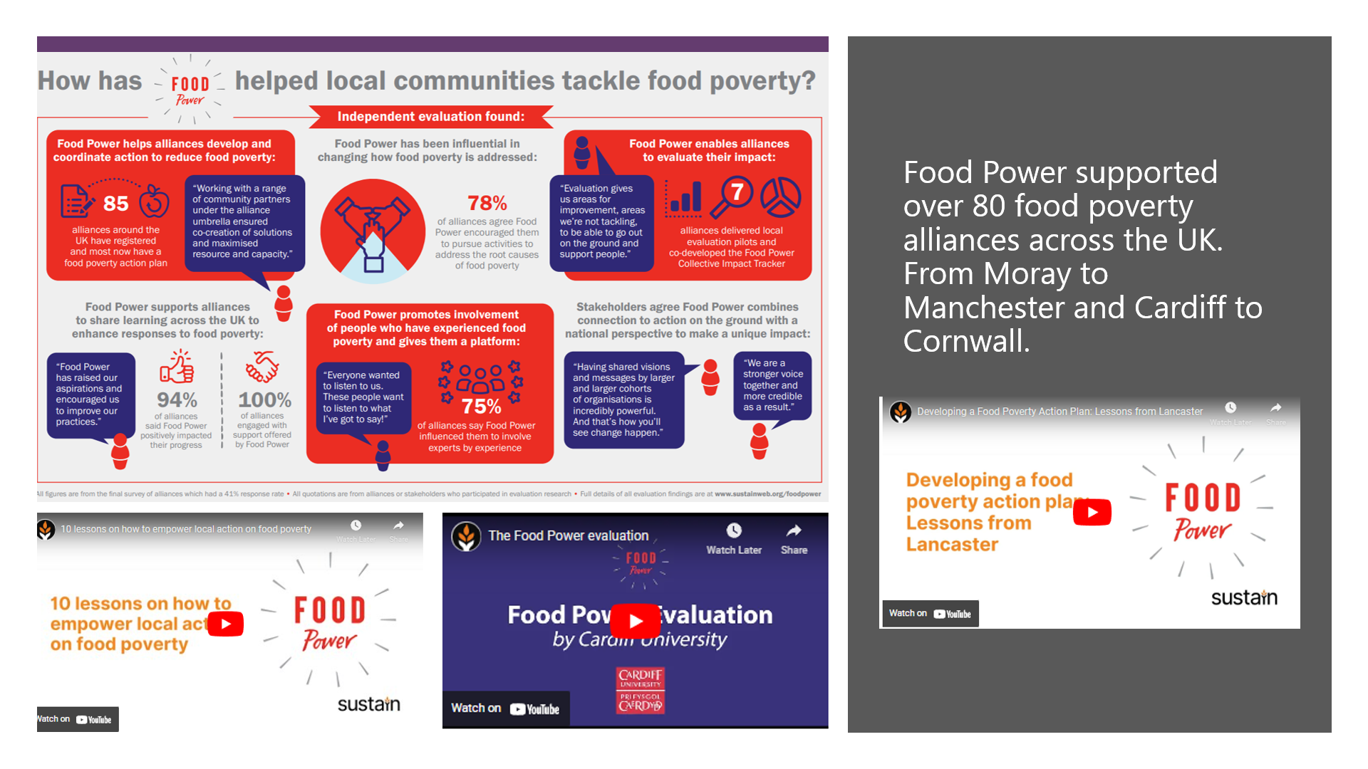

The Food Power evaluation concludes that:

‘Despite the challenges around demonstrating an impact on the most fundamental need - levels of food poverty there is reason to be confident that Food Power has contributed positively to this. Research into complex challenges like food poverty suggests that progress is most likely when actors come together to seek collective impact[11].’

A key finding was that 76% of alliances reported that they had been influenced by Food Power to consider how to involve experts by experience. A network of people with personal experience of food poverty were able to play an active role at both local and national level that was thought to have influence that might not otherwise have occurred. Examples of MPs visiting localities to understand food poverty and then take action were cited. Another interesting finding is that the programme was able to help some FPAs tackle rural challenges and a lack of joined up thinking, primarily by sharing practice and learning through webinars during the programme.

Key ingredients to enable FPAs to establish or mature were the provision of advice, coordinator resource to support each one, connection, best practice, learning and resources. Alliances appreciated support in sharing learning, guidance and other resources and having the Food Power core team as a 'critical friend'. Where there was a lack of capacity Food Power offered financial support for a coordinator or a key project.

A major study (2021)[12] of local food response during the pandemic concluded as one of its four key trends and findings that:

‘Food partnerships, food poverty alliances and other local networks continue to be powerful vehicles for collaboration, sharing of good practice, and developing a joint system-wide vision and accompanying set of actions.’ (and) 'During the March-August 2020 UK-wide lockdown, across the case study areas partnership working, coordination and collaboration were seen by participants as key to the success of local responses'

The study’s participants emphasised that any work done around local food response should ‘foreground sustainable collaboration in future responses.’ This should involve key actors including local government departments and public services that can help people access appropriate support and advice, as well as other third sector organisations.

[**Dundee Food Insecurity Network: a new model of accountable, responsive, and effective local government[13]**](https://heywoodfoundation.com/2021/06/24/dundee-food-insecurity-network-a-new-model-of-accountable-responsive-and-effective-local-government/) **- evidence for the future?**

In Dundee, community food projects have worked together with local government to develop the Food Insecurity Network. The Network has enabled a dynamic and dignified response to the food crisis, ensuring that both direct food provision and policy decisions responded to the lived experiences of people experiencing food shortages during the pandemic. The Food Insecurity Network is an example of a new model of practice (supported by The Heywood Foundation) that embeds accountability while ensuring people’s dignity. The opportunity therefore is to understand how this model of practice enabled the delivery of an effective city-wide response to food insecurity: to understand why it worked, how it worked, and how this model of crisis response could help us to rethink the very structure of local government. Future evaluation should help identify the outcomes from this model of practice.

**Examples**

**The East Riding Food Poverty Alliance[14]**

The East Riding Food Poverty Alliance was formed to provide support in the pandemic and is made up of 10 food bank and food pantry providers. Their vision was simple, to ‘achieve food security for all individuals across the East Riding of Yorkshire.’ Through the partnership’s combined efforts, nearly 12,000 food parcels distributed to almost 40,000 people. The project has 127 volunteers.

Key to the partnership was a Development Officer role (subsequently extended) to support the food banks and also to develop systems and processes and explore the progression from food bank provision to pantry provision to the development of social supermarkets providing food at reduced costs to those most vulnerable. The ambition was to move into sustainability for the food banks but also to help people become less reliant on food banks and encourage them to use social supermarkets. This will take form of membership, providing low cost food provision.

In addition, strategic development is an aim of the Alliance, to meet, share ideas, support each other, share distribution of food, share supplier information all of which has been required during this current crisis. In addition to the delivery of the project a monitoring tool has been developed to provide a consistent approach across the East Riding of Yorkshire. This was a challenging task as all Food Banks and Food Pantries operate within their own systems and maintain autonomy, but all understand the need for this consistent approach.

This model was set up to leverage funds from elsewhere and did successfully leverage over £220k from other sources. The Development Officer funding enabled the development of a Food Poverty Strategy, affording the time, money and space to collectivise the food providers' ambitions and intentions. To support volunteers further collaborative training was developed around the National Occupational Standards for food bank, food pantry and social supermarket volunteers, and there is a training log and record book, with plans to develop these into a ‘volunteer passport’ scheme. During the project, partners worked together to develop sustainable models of food bank support for communities across the East Riding, which led to the opening of three Social Supermarkets, with the latest opening in Goole in November 2021.

**Working in collaboration - Leeds Food Insecurity Taskforce**

The Leeds Food Aid Network exists to bring together a range of food aid providers, agency workers, the Council and members of the wider public, to tackle food poverty.[15] Partners agreed on a common vision for their work.

*“Leeds has a vibrant food economy where everyone is able to access local healthy and affordable food, produced in a way which improves our natural environment and embraces innovation.”*

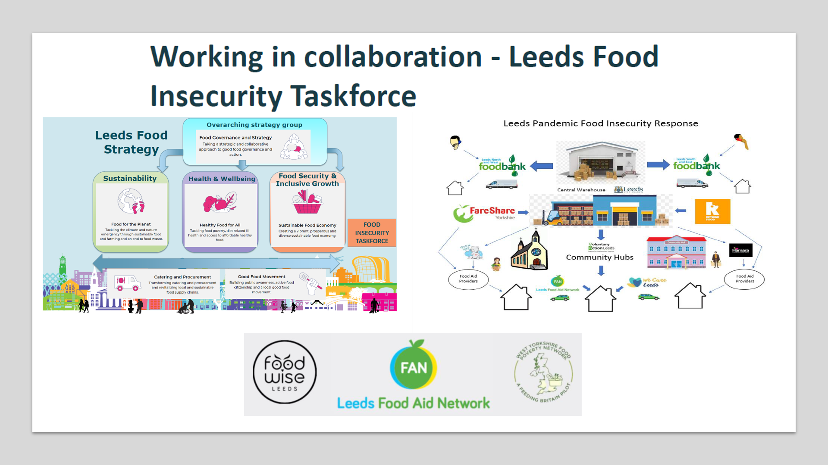

Evaluation highlighted the following enabling factors and learning points. Enablers:

Learning points

The structures that facilitated this collaborative model evolved from an initial primacy around public health and financial inclusion then to a broader hub model to enable the pathways to food resilience to be taken. Most recently, the network has produced a Food Resilience Toolkit (July 2021). For partners in the system, as well as organisational resilience, the aim is for more agile and better connected support services.

**Blackburn with Darwen Food Resilience Alliance**

This food alliance is notable for their focus on, and involving young people in the design, delivery and promotion of the work. Their youth empowerment exchanges, where young people lead conversations with other young people developed into dynamic forums, changed perceptions and responses to the impact of food poverty.

A small group of young people were ambassadors and champions in the borough and beyond for Blackburn with Darwen Food Alliance and their school. As a result, the partnership has raised the issue of food poverty in a community of young people. They have provided life changing experiences for four young people to act as ambassadors on a bigger stage– their school is so proud of what they have achieved. Longer term, the partnership will encourage all schools to be part of the youth empowerment forums and poverty proof schools. The partnership co-produced a film with young people ‘Edgelands’ and a campaign ‘’#DarwenGetsHangry’[16]

**Cheshire East and Warrington Food Networks** [17]

In June 2020 as a response to the COVID pandemic, the sub-regional Cheshire East Food Network was created. Whist there is a clear need and desire for the Cheshire East Food Network, it was the prospect of financial support that was the catalyst that brought it together. The Cheshire Food Hub is facilitated by CVS, and without this facilitation is unlikely to come together.

Building relationships across the area was important, for example a smaller network is already established in one town, and so they were careful to engage the leaders of this, to show that they were not taking over or duplicating their work. Through relationships made in the network food groups have been able to swap or sell ambient food to each other, distribute surplus fresh food quickly, and share plans and ambitions to support people to move out of food poverty. C

Participants identified the following success factors: * Supportive local community - welcoming to new ideas, providing donations; * Passionate and committed volunteers - nearly every project stated that it wouldn't succeed without these individuals; * Strong local partnerships and positive working relationships with stakeholders; * Sharing data and best practice with others; * Building on local assets and taking a co-production approach to project design and delivery; * Communication - with beneficiaries, partners and wider stakeholders.

**Enablers and challenges of partnership working during the pandemic and more generally for food response**

This section draws heavily on a key report[18] examining local food responses during the pandemic.

‘….across the case study areas, participants saw partnership working, coordination and collaboration as key to the success of local responses during March to August 2020. The partnership working may have been through food partnerships, food poverty alliances or other arrangements. The areas which had existing strong and active food poverty alliances or food partnerships considered this a significant enabler for a timely and coordinated response. In other areas, newly established partnerships, both formal and more informal, were warmly received and positively reflected upon[19].’

**Enablers of partnership working during the pandemic**

* Recognition of the need for a joined up approach and support, no one could do it alone.
* Getting the right people ‘round the table.’
* Having a lead organisation that can enable collaboration.
* Having established partnerships and networks in place.
* Goodwill and willingness to support the response.
* Learning from what was happening in other areas.

**More general enablers of collaborative working for food response**

* A range of actors driving for comprehensive approaches and system-wide strategies
* Recognising the role of third sector organisations and the limitations of food aid capacity and food supply
* Increasing the reach of community food projects and other services [20]
* Cash first approaches
* Peer mentoring offers a space for like-minded people to share alternative approaches to common challenge and brings structure and greater visibility to existing networks.

**Challenges of partnership working during the pandemic**

* Different agendas of the actors competing with each other.
* Initially, getting the right people ‘round the table.’
* Lack of co-ordination.
* Increase in inexperienced food aid providers.
* Continually changing provision made it difficult to communicate what was available.
* Accommodating an increase in inexperienced food aid providers.
* Continually changing provision made it difficult to communicate what was available.

‘We had a lot of self-appointed people who were very busy telling everybody else, including established charities, what to do…It's a bit galling when you’ve been doing the same job for 17 years. Maybe we’ve been doing it badly for 17 years and people who've been doing it for 5 minutes know better.’ (Charitable food aid workshop, West Berkshire)

**More general challenges of collaborative working for food response**

* Maintaining longer term relationships with experts by experience.
* Sustainability challenges owing to funding are commonly reported across the literature.
* The time to set up bulk buy processes.
* Obtaining referrals from health professionals.
* Bidding as a collective rather than individually as food providers.
* Ability to demonstrate impact of the model on the most fundamental need - levels of food poverty in the UK.
* ‘Sticking plaster’ support does not address the underlying issues behind poverty.
* Potential to create dependency rather than resilience depending on focus.

**Good practice**

Recommendations to local authorities in relation to supporting collaborative models.

* Ensure a coordinated local response.
* Develop wide networks.
* Develop and implement a food strategy and/or action plan.
* Work with and harness the third sector and communities.
* Ensure effective practicalities are in place.
* Identify effective ways to communicate amongst all relevant organisations.
* Learn from others .

**Retaining or sustaining collaborative approaches**

*Food Poverty Alliances:* It is unclear how sustainable these FPAs have been since 2021 and it would require contact with each one – where they still exist, or where they may have merged or reformed into another collaborative model – to locate their persistence and viability. Funding for the continuation of a dedicated co-ordinator post may have been a challenge beyond 2021, though there sustainability more generally is felt to have been achieved by ensuring FLAs / their localities are signed up to the Sustainable Food Place initiative giving continued access to shared resources. [FPA action plans](https://www.sustainweb.org/foodpoverty/actionplans/) are available to review[21] as is the collective impact tracker tool which enables FPAs to consider a structure for gathering data and evidence as part of their role to communicate the difference being made locally to people, the environment, communities and the wider food system.

*Partnership responses established as a response to the pandemic:* Some have endured and / or evolved. Just a small selection of examples in the literature include:

* One of the larger community food providers in Edinburgh was working to foster connections and networks between the smaller providers across the city. They felt this brought strength and energy to the efforts to tackle household food insecurity:
* The public health team at Greenwich Council were working to build a network of smaller providers and, in doing so worked to provide a means of doing this in a way that suited the third sector organisations, i.e., having individual conversations and not expecting for those conversations to all happen conveniently in a Food Action Alliance meeting
* A study participant from Swansea Council talked of work to update the Council’s Tackling Poverty strategy. The revised version would have a stronger emphasis on “the role of partnership working and collaboration across the board.

**Recent learning**

The Local Responses to household food insecurity across the UK during COVID-19 (September 2020-September 2021) study suggested these priorities for partnership s and alliances alongside local authorities and third sector organisations[22].

SUSTAIN: ‘The cost of living and local action by food partnerships (November 2022)’ brought together 123 practitioners to hear about good practice from 3 food partnerships.

**Key messages**

* The economic situation has grown worse. Residents feel less supported through this latest crisis than did during COVID. Networks are reporting more conflict between partners as resources grow scarcer.
* The funding environment has grown more challenging, and the supply of surplus food has reduced as economic conditions have worsened.
* Food partnerships play a key role ‘knitting together’ the public and VCSE responses to food insecurity.
* Central points and hubs with trusted relationships are key.
* The importance of coordination, capacity building and connecting roles between local authorities and VCSEs was also affirmed.
* The food surplus distribution model that many food partnerships were established with will need to evolve.
* Crowd funding is being used, with local authorities giving people the chance to donate their government support money. Some local authorities are choosing to match fund crowd funded initiatives.
* The local authority and Citizens Advice Bureau are key partners in these partnerships.
* Housing associations have the potential to be key partners (and feature in other literature reviewed for this study).
* Small grants with little or no administrative burden for grantees are seen to be agile and effective, and in one example, a £1k investment has led to a £12k further investment to scale up.
* In rural North Yorkshire, farmers could be encouraged to give over land for the community to grow food on in order to distribute.

**Brighton and Hove: Cost of Living: Innovation and coordination between Council and CIVS**

* A ‘Food Cell’ was established during COVID that provides a direct line between the food partnership and decision makers.
* The partnership has a member of staff seconded for 1 day per week to the local authority to support on food policy work. This increases knowledge of council systems and structures. For the local authority, it means that their staff can continue to focus on strategic food issues e.g., climate change while also managing the emergency response.
* The focus is on cash first approaches. The Children’s centre gives out vouchers rather than parcels using the ‘Huggg system’ supported by supermarkets. This simple system is judged to be easy to set up[23].
* The suggestions was made to bulk buy and use empty council premises as free spaces to store food.
* Volunteers could benefit from use of council parking permits.
* ‘In the Bag ’ is a popular scheme which includes recipes and ingredients to use surplus food.
* The food partnership seeks to influence and campaign and support groups to raise funding and increase the level of donations.
* They have focused on schools to drive more food donation and will then target businesses and individuals.
* With the local authority’s support, they have crowdfunded in partnership with CAB using a mechanism where those who can afford to donate the Government support given to them can choose to. To date, this has raised £45k (40% goes to food projects and 60% to the CAB).
* The big challenge is that the level of surplus food supply is falling. Surplus food has formed the basis of most food partnerships, so this poses a significant threat.

**Meeting the shortage of surplus food and donations. Sam Dyer, Cambridge Sustainable Food.**

* The focus on emergency responses is delaying more strategic work, for example on shortening supply chains or making Cambridge a less unequal city,
* Part of the partnership in Cambridge’s response is ‘grow and distribute.’ This includes a community farm, allotments and street-based projects to come together and grow food.

Of relevance for North Yorkshire is a farmer who gave over some land for community growing, and this co-veg field created 0.5 tons of produce.

* The importance of CAB for direct referrals and vice versa (all hubs have a direct line to CAB).
* £1k small grants fund “goes a long way” and is popular.
* The LA match-funded the crowd funding amount raised.

*“We cannot signpost people out of poverty, there’s not enough money in people’s pockets.”*

**Questions to consider**

1. There are a variety of collaborative models across the UK. Food Partnerships command the current weight of evidence around efficacy and value, however, national studies completed during COVID point to other forms being ‘powerful mechanisms’ too such as Food Poverty Alliances and Networks. York has had a Food Poverty Alliance which evolved into a Food Justice Alliance so its experiences and impact would be useful insight for this study. In North Yorkshire there is the Craven Food Partnership, Whitby Food Alliance, Ryedale Food Network and Selby Anti-Poverty Alliance. Insights, similarly, about the effects of these collaborative models would be helpful for this study in order to inform any wider strategic decision to be made about whether / how to encourage more or different collaborative models across York and North Yorkshire where this would lead to the desired outcomes referenced in this report section.
2. How could any existing / new collaborative model root the importance of lived experience into its design and production?
3. How can any collaborative model be viable beyond a time of heightened emergency and secure proportionate, adequate, dedicated co-ordinator resourcing?
4. How could any investment in new or existing collaborative models link into – indeed be supported by the resourcing - of wider strategies or local cost of living arrangements e.g., Food Strategies being developed in York and North Yorkshire (by Public Health); the development of Community Networks (as part of local government reform in North Yorkshire)? (See Lewes Food Partnership example below from the Cost of Living Hub)

Food partnership support via Cost of Living investment case[24]

1. How can the principles and practice of dignity be embedded into all approaches by collaborative models (see resources below from Nourish Scotland)?

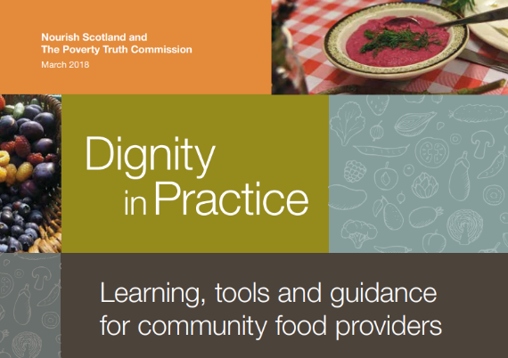

[Practice development resources - Nourish Scotland](https://www.nourishscotland.org/resources/practice-development-resources/)

1. Sources: The Value of Local Food Partnerships: UK Sustainable Food Places Evaluation Report. And: 2022 Food Poverty Alliances (2019)
2. This partnership also made a film highlighting the realities of growing up in food poverty. http://www.church-poverty.org.uk/edgelands/
3. ‘Holiday hunger’ pushes many families into food poverty and insecurity. While many children from low income families are entitled to free school meals during term time, there is currently no such provision during holidays. Local voluntary sector organisations ‘fill the gap’ in some places but this is far from universal.
4. The value of local food partnerships: Covid and beyond. Jones, M., Hills, S., & Beardmore, A. (2022). UWE Bristol: Esmee Fairbairn Foundation and National Lottery Community Fund
5. Faculty of Public Health. March 2019. 'Sustainable Food Systems for a Healthier UK: A discussion paper, page 12.'  <https://www.fph.org.uk/media/2409/sustainable-food-systems-for-a-healthier-uk-final.pdf>
6. NHS England. September 2019. 'Putting Health into Place'. Healthy New Towns programme. <https://www.england.nhs.uk/ourwork/innovation/healthy-new-towns/>
7. PHE. March 2017. ‘Strategies for Encouraging Healthier ‘Out of Home’ Food Provision A toolkit for local councils working with small food businesses’ Public Health England. (Toolkit page 20) <https://www.gov.uk/government/publications/encouraging-healthier-out-of-home-food-provision> 
8. Ways to care: Forms and possibilities of compassion within UK food banks. 2021
9. [Government Food Strategy: Much ado about nothing, an empty plate at a time of hunger and uncertainty | Sustainable Food Places](https://www.sustainablefoodplaces.org/news/gov_food_strategy_response_sfp_jun22-/)
10. Food Power Evaluation 2017-2021
11. https://collectiveimpactforum.org/
12. Gordon, K., Lambie-Mumford, H., Shaw, S. and Loopstra, R. (2022) Local responses to household food insecurity across the UK during COVID-19 (September 2020 – September 2021), published February 2022, available online http://speri.dept.shef.ac.uk/food-vulnerabilityduring-covid-19/
13. heywoodfoundation.com
14. Source: [ERFPA End of project feedback for lottery – Final | ERFPA - East Riding Food Poverty Alliance - East Riding Voluntary Action Services (ERVAS) Ltd](https://www.erfpa.org.uk/erfpa-end-of-project-feedback-for-lottery-final/)
15. Leeds Food Insecurity Taskforce brought together Leeds City Council including Financial Inclusion Team, Catering Leeds, Children & Families and Adults and Health. Food Partnerships and wider food systems representatives such as Leeds Food Aid Network, Fareshare Yorkshire, Rethink Food, Trussell Trust, Foodwise, Foodcycle. Academic partners including University of Leeds Voluntary and community sector organisations including Voluntary Action Leeds.
16. Image: https://www.instagram.com/p/Bx7gs7aAyp2/?igshid=MDJmNzVkMjY%3D
17. Source: Food Insecurity: Understanding local delivery, impact and innovation in the North East Riding (2021)
18. Gordon, K., Lambie-Mumford, H., Shaw, S. and Loopstra, R. (2022) Local responses to household food insecurity across the UK during COVID-19 (September 2020 – September 2021), published February 2022, available online http://speri.dept.shef.ac.uk/food-vulnerabilityduring-covid-19/
19. Lambie-Mumford, H., Gordon, K., Loopstra, R. and Shaw, S. (2021) ‘Comparing local responses to household food insecurity during COVID-19 across the UK (March – August 2020), published July 2021, available online http://speri.dept.shef.ac.uk/food-vulnerability-during-covid-19
20. As specific groups have been disproportionately affected by the pandemic and its aftermath, we consider that targeting and tailoring of support warrants particular attention from practitioners and policymakers.
21. [Food poverty action plans | Sustain (sustainweb.org)](https://www.sustainweb.org/foodpoverty/actionplans/)
22. Page 51, table 6
23. <https://www.huggg.me/public-sector>. Creating shared databases and systems was identified as a particular challenge, particularly as no one has the time to do this.
24. [Lewes District Food Partnership: Partnering with Lewes District Council to develop a food security strategy | Local Government Association](https://www.local.gov.uk/case-studies/lewes-district-food-partnership-partnering-lewes-district-council-develop-food)