6.11 Community food initiatives / projects

This section is based on a detailed review of 11 of the most relevant studies, together with additional research from the grey literature.

Model definitions and descriptions

Research from Scotland provides a working definition and framework.

“Community food initiatives (CFIs) aim to ensure that people have access to affordable, acceptable and adequate food.”

CFIs have a variety of aims and may work within a geographical community or a community of interest. Public Health Scotland’s community food work has focused on supporting CFIs that aim to address or mitigate health inequalities. CFIs have supported organisations that aim to tackle access, affordability, acceptability, availability and/or the adequacy of good food within their communities.

CFIs come in a range of shapes and sizes, but fall into three main groups:

- Initiatives that run food activities as part of their wider work (e.g., youth clubs, Development Trusts).

- Initiatives whose core work is about food, e.g., lunch clubs, community cafes, community allotments, community shops, food or meal delivery, food-based-social enterprises.

- A third type of food organisation are ‘anchor’ organisations that support community food activities locally by supplying food, outreach activities or providing facilities for other organisations and agencies (e.g., cooking classes, training, training kitchens).

CFIs deliver activities for a range of reasons, including to:

- Address food insecurity (e.g., food banks, social meals).
- Increase food access: fruit and veg barras, community shops, shopping or meal service.
- Mitigate social isolation and/or promote good nutrition: lunch clubs, community cafés, social meals.
- Develop individual skills and/or promote community development/environmental aims: food growing, cooking skills, community-led research.
Community food projects

The Eden Project Field Guide to Community Food Projects meantime has developed a useful framework to better understand the range of activities being carried out. The underlined models feature predominantly in this section based on evidence that was available for review at time of writing, though others are referenced in terms of examples where appropriate too.

Growing food | Be enterprising | Make something | Sharing and celebrating
- Community food garden / community gardening  - Allotments  - Community orchards  - Community growing on farmland  - Home growing and shared gardens  - Guerrilla gardening  - Wild food and foraging  - Community-supported agriculture (CSA)  - Livestock and bees | - Food co-ops and buying groups  - Box schemes  - Community shops/retailing  - Community cafes  - Pop-ups  - Food hubs  - Farmers markets | - Using up food that’s being wasted  - Making and selling your own produce  - Sharing your skills  - Community composting | - Sharing food in your community  - Supper clubs  - Lunch clubs  - Food Swaps

“Food is a great way to bring people together in your community. You can get your local community growing, cooking and sharing food that is not only good for them, but also the environment. There are many fantastic examples of community food projects across the country, which are often about more than just food. Many of them also aim to improve the community and the environment. Projects are often set up to create an alternative to the way most people shop, cook and eat or to learn new skills. Community food projects are all about allowing local people to take control of where their food comes from and connecting them with each other and where they live. A food project is a great way to get everyone involved, bring communities together, helping to create a sense of local pride.” (Eden Project Field Guide)

Community retailing

Community Food and Health (Scotland) (CFHS) defines community retailing as:

“Community groups selling affordable, quality foods within or for low-income communities.”

All community retailers focus on selling fresh fruit and vegetables, and many sell a small range of other healthier foods. There are also community retailers, usually community shops, that sell a wide range of food and other non-food products.

Every community retailer is different because they have been set up to meet differing and specific needs within their communities (e.g., limited access to shops, poor-quality fruit and vegetables available locally or few opportunities to meet other people). When, where and how they run, how they are managed, what they sell and what other activities they provide (if any) reflect these differing needs.

Evidence

This section begins with international evidence, which draws on a larger evidence base than UK-only studies. Examples that illustrate the different types of community food initiatives / projects are then presented.

International evidence. Interventions to address household food insecurity in high-income countries. (2018)

- This review evaluates evidence on interventions intended to reduce household food insecurity in high-income countries. Research on social protection interventions suggests both cash transfers and food subsidies reduce household food insecurity.

- In contrast, research on community-level interventions, such as food banks and other food programmes, suggests limited impacts. Alternatives to, or enhanced, food banks such as community shops or community kitchens have become common, but evidence also suggests they may be limited in effectiveness if they do not reach people experiencing food insecurity. This review highlights the difficulty of trying to address household food insecurity with community-based food interventions when solutions likely lie upstream in social protection policies.

‘Growing food’ (international evidence)

Community Gardening: Stress, Well-Being, and Resilience Potentials

- A Singapore study (2020) found community gardeners to have significantly increased subjective wellbeing, optimism and resilience compared with a control group. This indicates that engagement in community gardening may be superior to individual/home gardening or non-gardening outdoor activities. These novel results also indicate some potential for mental health benefits in urban environments, specifically in terms of subjective well-being and resilience. These findings have implications for future research in clinical psychology, mental health promotion, and policy (n=111)

- An impact study of community gardening used in domestic violence shelters in California found that it eased adjustment to the shelter and relieved stress and improved mood (n=81)

- A study of 50–88-year-olds showed significantly lower levels of perceived stress for the allotment gardeners compared with participants who performed indoor physical activity. However, there was no significant difference in the perceived stress levels between the allotment gardeners and home gardeners, or those who performed outdoor physical activity.

- Community gardening has been proposed as a means to foster good health and well-being by furthering resilience on three levels (individual, social, and natural environment), strengthening social resilience, and motivating neighbourhood improvements, particularly in deprived areas.

- Evaluation of The London Food Poverty Project for low-income communities identified community gardening as a conduit for connecting people, building confidence, wellbeing, and improving both gardening and cooking skills.

- In New South Wales, participants of the Community Greening Program reported a significant increase in their shared emotional connection with the community as measured by a quantitative survey at the beginning of their participation and up to seven months later. Participants who were not eating any fruit and vegetables or cooking healthy food at the start had changed these behaviours at the post test. Qualitative data also revealed positive changes in both inter- and intrapersonal outcome

‘Be enterprising’

Food co-ops and buying groups. Shaping more resilient and just food systems: lessons from the COVID-19 pandemic.2021

- Community-led solutions such as community supported agriculture and food cooperatives present a promising way to enhance consumer equity and justice through engagement with food systems. Public funding could support community-led action to build enduring support infrastructure and organisations.
- People-centred food systems require ‘transformative governance’ which is rooted in meaningful engagement from civil society.
- Public sector procurement has the power to exert change by sourcing sustainably produced food that supports public health objectives. But to supply large public contracts, small-scale producers require intermediaries such as processing facilities. Public investment in this infrastructure would enable smaller-scale producers to access new markets and support expansion, creating a more equitable producer landscape.
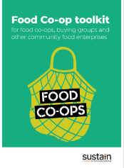
Side note:

Sustain reports that More and more communities are setting up food co-ops so they can get good food at an affordable price and have more control over where their food comes from. Co-operation is all about people working together to achieve something they couldn’t do on their own. In the case of food co-ops a group of people volunteer their time and pool their buying power so they can order produce at cheaper prices, direct from suppliers and local farmers.

Sustain has published a toolkit that helps anyone wishing to set up a food co-op and an interactive locator map
Map | Sustain (sustainweb.org)

Community cafés
Supporting and Strengthening Community retailing (2018)
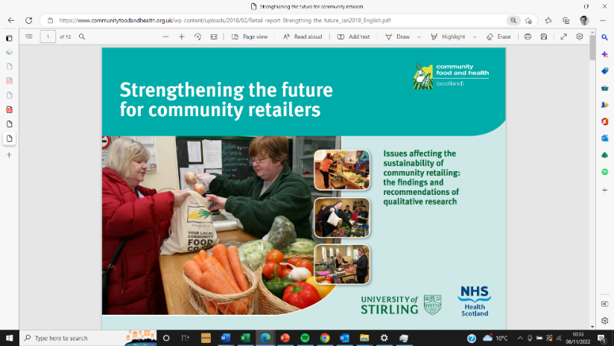
- This study recognises that community retailers want to stay locally based and run. However, it suggests that by working together, community retailers could reduce their costs and amount of work needed to run and develop their services. This could include buying produce jointly (to reduce the cost) and working together to apply for funding. The research also suggests that community retailers could look at how the resources they already have (e.g., premises and transport) could be used more effectively among themselves, or with other third sector groups.

- The operational recommendations focused on training and information needs. All would gain from making it easier to share information between community retailers, for example using an online resource. Such a resource base could also include training materials to develop skills and expertise. The range of material provided could include support with business skills, retail skills or governance of community retailers.

- The time taken to source good quality produce all year round, at the best possible price, can be an issue for community retailers. Depending on price and availability, they may buy from a number of suppliers, including wholesalers, farmers, local producers and community food networks. In addition, checking the quality of produce to maintain standards may take staff away from other work (which affects capacity). The research also found that community retailers may find it difficult to work out how much produce to buy, which could result in high waste levels (between 20% and 30%).

Community shops

An Eden Project Guide to Community Food Shops (2015)

- There are over 300 community shops in the UK, and they are mostly found in rural areas. They tend to be very responsive and listen to their customers’ requests. Some have taken over commercial shops that have closed, others have started from scratch to address a local need. Community shops get a group of people with a range of different skills and experience together, and often rely heavily on volunteers to run them.
‘Make something’

- Brighton & Hove Food Partnership includes a scheme called ‘In the Bag.’ Sponsored by Sussex Cricket Club, the recipes are designed to encourage families to cook together. The bags include activities for children. Importantly, the ingredients are chosen to use surplus food that would otherwise go to waste.

‘Sharing and celebrating’

Navigating Storms: Learning from Covid-19 food experiences 'Food Vulnerability During Covid-19' Participatory Panel. (2021)
- Panel members were keen to emphasise the power and value of local projects. Eating together and sharing food creates a distinctive camaraderie, and relationships reduce stigma and enhance support.
- Volunteering increases a sense of purpose and self-worth. For some, the opportunity to be involved in tackling food waste and encouraging healthy eating was also significant.
- As well as existing projects a lot of informal, new work began. "Community responses were perceived as 'natural'. Communities have long come together, both in 'ordinary times' and in a crisis.”
- The Panel felt projects already ‘on the ground’ were well placed to plug gaps in statutory provision, more in touch with local needs and better able to harness and channel local support.

‘Sharing food’

Shaping more resilient and just food systems: lessons from the COVID-19 pandemic.2021
- As a direct reaction to COVID-19 lockdowns, self-defined Mutual Aid and COVID-19 community response groups sprang up around the UK. The principal functions of mutual aid groups have been to support neighbours in self-isolation by collecting food shopping and prescriptions and sharing advice and information.
- They have also become forums for sharing food and plants and have linked with other community efforts coordinated through charities, and community and religious groups focused on food and meal provisioning.
- Pre-existing community food projects described huge increases in offers of help with food growing, cooking and distribution.

Outcomes

The outcomes are derived primarily from the following evidence sources:
- Local responses to household food insecurity across the UK during COVID-19 (September 2020 September 2021). An analysis of experiences from 14 local areas from around the UK and recommendations for future policy and practice.
- A snapshot of Covid-19, food insecurity and community food initiatives What happened and what can we learn? (2020)
- An Eden Project Field Guide to Community Food Projects (2015)
- Community Gardening: Stress, Well-Being, and Resilience Potentials (2020)
- What are the health and well-being impacts of community gardening for adults and children: a mixed method systematic review protocol. 2014
- The contribution of community food initiatives to national food and health programmes (2013)
- Shaping more resilient and just food systems: lessons from the COVID-19 pandemic (2021)
- The Food Ladders Project - Mapping the Geographies of Food Provision in Sheffield. 2022
- Navigating Storms: Learning from Covid-19 food experiences 'Food Vulnerability During Covid-19' Participatory Panel. (October 2021)
- Community and Health Scotland Strengthening the future for community retailers (2018)

Outcomes for individuals from community food initiatives / projects (will vary per model and the extent to which people come together to do something as part of a CFI or project)

- Improved diet/food access: fruit and veg barras, community shops, shopping or meal service.
- Mitigate social isolation and/or promote good nutrition: lunch clubs, community cafés, social meals.
- Develop individual skills and/or promote community development / environmental aims: food growing, cooking skills, community-led research.
- Easier to get involved compared to higher commitment alternatives e.g., community gardening.
- Wellbeing, optimism and resilience.
- New friendships, camaraderie, reducing stigma e.g., if there is a sharing, celebrating, growing or eating together element
- Reduced social isolation, “A place to go”
- Increased self-awareness / understanding of situation
- Shopping locally
- Reduced food supply chain and cost of food disposal.

Outcomes from community food projects can be tracked in these ways too

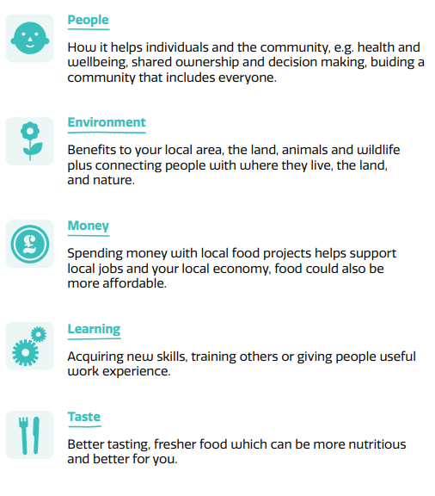

Examples

Granton Community Gardeners – community development in action (North Edinburgh in a locality recognised as an area of deprivation)

This case study looks at how a community gardening project started in 2010 from a conversation between neighbours about a small piece of unused land and has grown into a local charity hosting regular community meals and events, group gardening sessions and tuition, and a number of thriving connected projects including a bakery, a chicken co-operative, and a free-shop.

The main site is managed by a working group of staff and core volunteers, who oversee shared food growing, as well as all the different uses of the garden, including hosting activities for school, and other young people’s groups, hosting large community events, and being a resource hub for local gardeners.

The project has found that for a lot of people, the diminished individual responsibility, and increased sociability and mutual learning of shared work makes it easier to get involved, compared with other higher commitment alternatives (e.g., allotments).

With three open gardening sessions per week, their approach is that ‘everyone’s welcome, but never obligated.’ There is enough of a core group of volunteers to keep on top of things, so that other people can take part when they want to.

A natural progression of the project’s work has been setting up community meals. At the very first meals, people taking part were asked to bring a dish to share that included produce from their own garden or a community garden. These attracted up to 20 people. In 2013, a Harvest meal attracted 60 local people, and that winter, a Burns Community Ceilidh sold out 250 tickets which have since become a very popular annual local celebration and have sold out for six years in a row.

A culture has grown of sharing regular weekly meals featuring food grown in the local gardens, but most is sourced from FareShare, and other donations. Food is prepared by a cooking team of volunteers led by an experienced chef and is provided free/donation. Everyone regularly participating is encouraged to contribute in some way – for example by helping wash up, setting tables, donating produce, or by delivering meals to people unable to get to the venue. The meals are open to anyone. Those experiencing food insecurity can access nutritious tasty free food, with dignity.

“It has also been interesting to observe over time, community connections and mutual understanding, gradually strengthening simply as a result of 30-50 neighbours from a wide range of age groups and cultural backgrounds, eating together around large tables each week.”

For more details about the enterprising elements that have evolved such as the chick co-operative, the Granton Garden Bakery and the Free-Shop please see full case study here

Initially this project began with a budget of £10 donated at the first family gardening day and some loose change they dug up, along with donated tools, plants and seeds. In 2012 a grant from the Big Lottery Fund Awards for All programme was used to run a ‘grow your own’ course which attracted new members to the project. Later it was awarded funding from the Voluntary Action Fund to run volunteer capacity building training. More recently the organisation has been funded by The Scottish Government’s Investing in Communities Fund, The National Lottery Community Fund, The Robertson Trust, and STV Children’s Appeal.

Further community gardening case studies are found here

Kate’s Kitchen – Pay What You Can Community Cafe

Kate’s Kitchen (KK) is based in Dumfries and Galloway. It runs a ‘pay what you can’ café which is open to anyone. The café offers full lunches twice a week, and light lunches another two days when group activities are running. It is funded through the Scottish Government’s Fair Food Transformation Fund. It also runs a gardening service. Volunteers are essential to KK. To ensure continuation if and when funding ceases, the staff have been working with them to develop the skills required to take over ownership of the service. Some of the volunteers have been service users or customers in the past: some still are to some extent but are moving towards a more positive destination and less supported volunteering. Evaluation findings showed that for most, but not all, the services had been life-changing, and had given their life a purpose. Outcomes reported included more confidence building new friendships and having somewhere to go were all highlighted by other service users. The questionnaire also highlighted the transport costs and difficulties faced by a quarter of those surveyed. This finding has since been used to inform funding applications for an outreach service. Further community café case studies are published by Community Food and Health Scotland here

Leeds based project highlights social connection through food growing
Growing Friendship is a new project providing seedlings, tools and other inputs, as well as training workshops for asylum seekers, refugees and people in food hardship to grow and harvest vegetables at home or other growing spaces around Leeds. It is the latest in a series of #getgrowingleeds initiatives that have emerged since the pandemic to support people to grow food and is funded by The National Lottery Community Fund. The seedlings are grown by experienced volunteer food growers from around Leeds and dropped at Meanwood Valley Urban Farm collection point ready to be picked by anyone interested in growing. The project gives out growing advice via a community Facebook Page. They have run growing workshops giving out growing packs of seedlings; compost; pots and tools for people who would struggle to get their own. The team was planning Harvest workshops to celebrate what everyone has grown and swap recipes and cooking ideas.
“By encouraging experienced food growers to grow extra seedlings to share with people who are new to food growing, this project creates a support network of new food growers and new friendships that wouldn’t happen otherwise. This is what inspired the name of the project in the first place. We hope that new friendships along with delicious fresh vegetables and confident new food growers result from this new collaboration.”
Sustain are encouraging more areas to launch Veg Cities campaigns and get local businesses and organisations making veg pledges. Veg Cities is a campaign of Sustainable Food Places and is run in partnership with Peas Please.
Learning

- The Eden Community Food Project Guide recommends being creative to maximise community benefits e.g.
- Using local green spaces or unloved areas to create projects that build the knowledge and skills to grow fresh, local, seasonal food
- developing local enterprises and jobs around the growing and processing of food
- creating opportunities for people to learn and to involve schools and young people
- linking local people making food (producers), selling food (retailers) and those who buy it (shoppers)
- promoting healthy living and improving general wellbeing
- ensuring money is spent and stays in the local economy sharing and celebrating food.

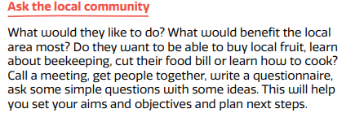
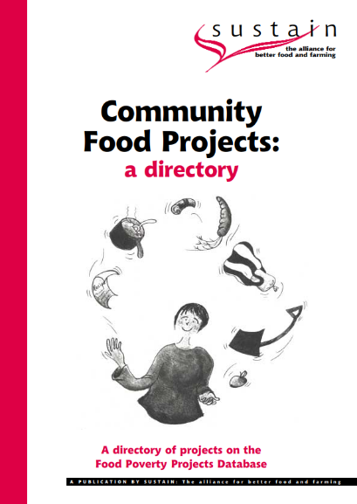
The Guide has practical tips for setting up a project along with thoughts about the resources required, assets to identify and challenges likely to be faced with each type of project. The key tip is:

The Sustain archive also includes an old publication though it is unclear whether a similar resource exists now. The directory listed projects including food co-operatives, community cafés, school breakfast clubs, cooking clubs, food growing projects and farmers’ markets. It was designed for anyone with an interest in local food initiatives, especially anyone running or trying to start a community food project.

Sustain also have a series of guidance leaflets called ‘Cracking Community Cafes!’ to assist with the operation of this model.

This resource - community food activity | Community Food and Health (Scotland) is also helpful to better understand how community food activity has been classified, described and evaluated in Scotland over many years and includes practical case studies for different models referred to in this paper

Making the case for community food initiatives

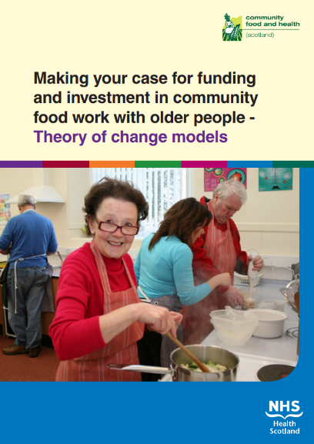
A 2014 publication focuses on the work of community food initiatives working with older people helpful to CFIs in building and articulating the case for their work with older people. It gives an overview of the needs, contexts and strategies engaged in developing food work with older people, described in the format of a simple theory of change model. It is based on consultations with CFIs working with older people and there are illustrative models for each of their projects in the appendix. There is also a brief review of the limited research evidence to support the contribution of this work to preventative spend. The different project types ‘theorised’ suggest that desired results might include the following:

Allotment model
- Reduce isolation and promote community connections for men diagnosed with dementia through taking part in a physical activity, namely gardening, along with other people affected by dementia in a safe and creative environment.
- Grow a range of different foods and provide the opportunity to think about healthy eating as well as take produce home.
- Provide time out and informal therapy and support for carers, with the result that ‘they feel better able to cope as a carer.’
- Promote best practice and ways of working creatively with men affected by dementia, building on learning from the drop-in cafés that run in different locations in Glasgow, through providing food-based gardening activities for older men.
- Provide volunteers with transferable skills in a specialist area

Community food model
- Access by older people to low-priced fruit and vegetables and basic foodstuffs in suitable small quantities, tailored to individual needs.
- Skills development among volunteers and workers in using the resource pack to share knowledge and understanding of the needs of older people.
- Increased understanding among health and social-care staff, including sheltered housing wardens, and older people themselves of nutritional messages specific to older people.
- Better health and wellbeing of older people, based on a better understanding of what a healthy balanced diet means for individual older people, with access to support to achieve this.

Lunch clubs model
- Promote an independent way of life among older people who are not housebound, but have difficulties shopping for health reasons, and for whom cooking for one is quite expensive.
- • Provide access to social activity involving cooking meals from scratch with other older people in the community.
- • Increase affordability of nutritious food through subsidised service charges.

Questions arising

- What is our map of provision in York and North Yorkshire like when compared to the 4 community food project framework typologies derived by the Eden Project?

- What has been, or is, the current appetite from local residents to develop their own community food initiative / project and if they wanted to, how would they get practical advice and tips beyond the resources identified in this paper?

- Has any local self-evaluation been tried by those running the community food projects to understand the benefits they deliver / their local efficacy?

- Is there any evidence of York and North Yorkshire landowners being incentivised / encouraged to give over pockets of their land for communities to grow food on?

Source: A snapshot of Covid-19, food insecurity and community food initiatives | Community Food and Health (Scotland, 2020)
community_food_projects_e-book_0.pdf (edenprojectcommunities.com)
Source: Meeting the shortage of surplus food and donations. Sam Dyer, Cambridge Sustainable Food. Part of a webinar entitled ‘The cost of living and local action by food partnerships. SUSTAIN (November 2022)’
Source: https://www.communityfoodandhealth.org.uk/wp-content/uploads/2018/02/Retail-report-Strengthing-the-future_Jan2018_English.pdf
Source: https://bhfood.org.uk/directory-hub/in-the-bag-recipe-kits/
Granton Community Gardeners – community development in action | Community Food and Health (Scotland)
Community gardening | Community Food and Health (Scotland)
Sycamore Tree Café – evaluating their place in the community | Community Food and Health (Scotland)
New Leeds based project highlights social connection through food growing | Sustain (sustainweb.org)
Cracking Community Cafés: Promoting your café | Sustain (sustainweb.org)
Making the case | Community Food and Health (Scotland)
Community café self-evaluation programme | Community Food and Health (Scotland)

