6.2 Low-cost community food retail

Definition
‘These are variously called local or community pantries, larders, or fridges, social supermarkets or food clubs. Though they often also rely on redistributed surplus food, they differ from food banks because people usually pay a small amount either as a membership fee or on a per-use basis and then get to choose from the selection items available. Making fresh foods available are also usually a feature of these models.’ For the purpose of this report we have included pantries, larders and social supermarkets (sometimes called Eco Shops or Next Step Shops in parts of the country)and community shops/stores in the definition. Fridges appear to be a free food access model (see 6.1) whilst food clubs are found in the community food hubs and clubs report section.
How they work
Though they often also rely on redistributed surplus food, they differ from food banks because people usually pay a small amount either as a membership fee or on a per-use basis and then get to choose from the selection items available. Making fresh foods available are also usually a feature of these models. In one of the earliest studies exploring this phenomenon from Austria in 2011 it was reported that ‘social supermarkets (SSMs) play an increasingly important role in the Austrian retail scene. They sell food and consumer goods which they receive for free from manufacturers and retailers at a 70 percent discount rate to people at risk of poverty.’ The unique characteristics of SSMs and their classification within the spectrum of retailers with a social mission confirm that SSMs can be regarded as a new type of retailer.
Evidence
Research in 2021 reported that there was evidence of an increasing appetite for and use of low-cost community food retail models and development of this kind of provision during 2020-2021 including a rapid growth in pantries. In Leeds, for example, there had been the development of 18 food pantries, 12 with Family Action, 1 with Church Action on Poverty and 5 with Health for All. One participant described the pantry model which they were trialling in Moray: “On a more practical level, we're trialling pantries, which is zero waste. It’ll be open to everybody for a very small fee. So, you pay £2.50, but you're getting £10, £15 worth of food, but we would also have some free food there, as well. It's just trying a different way to give people the choice and the access to food and taking away the stigma around it as well.” (Charitable food aid workshop, Moray)
As well as new low-cost community food retail models being set up, the report referenced an existing food bank in Bradford that was transitioning to a low-cost model. Whilst these developments in low-cost community food retail models were generally perceived to be positive, participants also highlighted that there may always a need for some free food aid
Although there are distinctions between low-cost community food retail and food banks, often on membership, cost, eligibility criteria and referrals, one participant noted that the distinction between food banks and food pantries may not be well understood including by their target groups, creating a “messy” space: “Part of the consultation [we did] with the Food Family's Network across Edinburgh, which Food Power supported, was [asking] what is the difference between a food bank and a food pantry? And people just- they don't know, they don't know. They just know it's a place for food, so it's a bit messy at the moment, to be honest with you.” (Charitable food aid workshop, Edinburgh).
Emerging evidence for social supermarkets – Eco Shops in Middlesbrough
‘The review of social supermarkets in the UK by the research team concludes that the evidence is sparse.’ Further research is therefore being completed in the UK in 2022 that may generate an evidence base for those wishing to develop these models, for example, a proposed project with evaluation to help secure funding for ongoing Eco Shops in Middlesbrough. This is a social supermarket model being coordinated by Middlesbrough Environment City with support from South Tees Public Health.
Eco Shops are referenced in the Food Power Evaluation (2017-2021) where local food poverty alliances are credited with encouraging models of this nature:
‘Alliances have been encouraged by Food Power to focus on working to tackle the root causes of food poverty and have taken a range of approaches to this, including cash first, healthy eating, education, co-creation, mutual aid, and community participation models. A good example of Food Power’s influence in this regard is the Eco-shops in Middlesbrough. These were created by combining the alliance’s local knowledge with learning from Sustain’s sustainability guidance and Food Power’s anti-poverty resources to create Eco-shops that address unmet need for affordable healthy food:
“Probably the biggest change we’ve made is the ability to develop Eco-shops, a stigma-free poverty intervention. We’re massively proud of it. […] people tell me how invaluable it’s been. And how much they’re supported. And that’s what it’s about. And them not feeling lesser of a person for it. That’s the biggest achievement from Food Power” (Middlesbrough Food Partnership representative).”
Building on this narrative from 2021, Eco Shops are thought to help achieve Public Health related outcomes and are described as fundamental to the ongoing work of Middlesbrough Food Partnership (MFP) and Food Power Alliance (FPA). The evaluation of the Eco Shop model will help secure financial support. In 2022, the research aims to understand how food insecurity and stigma can be reduced and whilst improving access and availability to healthier foods in socially and economically deprived communities. The objectives of the research are to explore how social supermarkets are used throughout the UK; determine the availability and accessibility of social supermarkets across the North-East and North Cumbria; understand how people in the North-East, specifically Middlesbrough, use and perceive them; and explore ways of encouraging customers to buy and use healthier social supermarket items. There are proposed methods for public involvement.
1: Resource development: Within this project, we will work alongside members of The Middlesbrough Eco Shop Task and Finish Group (TFG) to develop a survey, interview questions and other project materials to ensure that it is fit for purpose and applicable to the population.
2: Peer researchers: We will recruit and involve peer researchers in the data collection process, empowering and engaging with communities in a more impactful way.
3: Steering group representatives: Representatives from both the TFG and peer researchers will be invited to steering group meetings to ensure they are involved throughout the duration of the entire project.
Findings will be taken forward by the TFG to help develop, mobilise and embed strategies deemed most acceptable and those with future potential.
Outcomes
Key sources where the outcomes (below) were evidenced for this section of the report
- Social Supermarkets: Typology within the spectrum of Social Enterprises (2011)
- East Riding Food Poverty Project Alliance Report (2021)
- Food Insecurity: Understanding local delivery, impact and innovation in the North East Riding (2021)
- Local responses to household food insecurity across the UK during COVID-19 (September 2020 September 2021).
- Community social supermarkets: understanding how they shape access and availability to healthier foods in food insecure communities (2022)
- Working in collaboration - Leeds Food Insecurity Taskforce (2022) and the Food Resilience Toolkit
- Lewisham Homes' Community Food Stores Impact Evaluation (2022)
- Food Power, Final Evaluation Report (2021)- Eco Shop references
- Interim Evaluation Report: Community Food Hub in Foleshill, Coventry (2021)
- The Food Ladders Project - Mapping the Geographies of Food Provision in Sheffield (2022)
- Navigating Storms: Learning from Covid-19 food experiences 'Food Vulnerability During Covid-19' Participatory Panel (2021)
- Releasing social value from surplus food Evaluation Final Report (2020)
- FareShare network; The Wasted Opportunity (2022)
- Community supermarkets could offer a sustainable solution to food poverty Demos (2015)
- Synthesis of food pantry and community shop/store outcomes by Dr Megan Blake, University of Sheffield (2022)

The most notable outcomes referenced in the literature include:
- Community empowerment through a process of developing a local social supermarket
- Increased resilience / less dependency e.g., not reliant on food banks as much as before
- Less worry and stress by being able to stretch budget; less spent on food = more on other bills
- Improved sense of belonging, dignity / reduced stigma by accessing a model that is open to the whole community
- Choice / individual empowerment
- Access to healthier, fresh food options not typically available in food banks
- Opportunities to volunteer build skills and confidence, and these roles are often taken by people who are/were struggling themselves and seek to give back
- Reciprocity
- Self-efficacy – planning the cooking of food with greater confidence (especially where the model includes an education / cooking together element). Please also see 6.8 an example of self-efficacy being improved through a novel food pantry model in Hartford, America.

A synthesis of outcomes derived by food pantries has been included below for a slightly deeper dive into this model. The benefits include saving money on grocery bills, saving food for landfill, enhancing nutrition and food variety, knitting neighbourhoods together and developing employability.
Benefits to members (individuals and households)
- Improves food and nutrition security: Pantries provide availability, access, and stability of wide variety of healthy and nutritious food to their members. The weekly access to more fruits and vegetable, protein (such as fish, meat, and eggs) means members can choose to eat more healthier food and less process food with more members trying new nutritious food which they could not previously afford. Pantry membership, both the financial savings and the food on offer through the pantry, play important role in helping families experiencing moderate or severe food insecurity
- Improves Wellbeing: improve self-worth and reduce stigma, there is no stigma attached to using the service. Being able to buy good quality food at reduce prices improve self-worth. Provide opportunities for members and non-members alike to volunteer, thereby building confidence and gaining valuable employable skills. Members also build their confidence around food/cooking classes.
- Health outcomes: Being a member /user of the pantry improves mental health and reduce anxiety – reduces financial worries. Reducing people anxiety of being able to feed themselves help improves their mental health.
- Improves household income: For a household visiting local pantry once a week could save £780 a year. A typical food basket of pantry is valued at £20 saving members over £15 a visit. Thus, improves members financial wellbeing – savings are used to settle debts and pay other household bills, or buy more quality food from the supermarkets (food they could not afford before)
- Reciprocity: Food pantries operate often by asking for something in return. In this model, for a small fee, people select or receive a greater value of groceries that what they could purchase at the supermarket for the same amount.

Community benefits/outcomes:
- Community resilience and social infrastructure: Pantries play an important role in developing and strengthening local
- communities. Members feel more connected to their local community through being a member of pantry, enabling members to build social networks -socialising and meeting new friends and felling valued as pantry members.
- Investing in community: Pantries can also play a part in strengthening the local economy. Several Pantries reinvest their membership fees to purchase additional stock, taking care where possible to support local businesses with their purchases.
- Connecting with community services /Strengthening communities
- The pantries act as food hub by offering additional support (skills and training – cookery classes/demonstrations) to members, which help members to learn how to cook simple and nutritious meal. Connect members to other social and service providers (debt service recovery groups, local welfare support scheme, pastoral, and spiritual support; benefits and legal advice), therefore able to help members to deal with the root causes of food poverty.

6.2.1 Social supermarkets

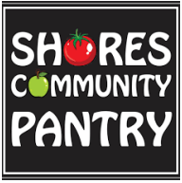
Examples of social supermarkets, sometimes branded or interchangeably called pantries, Eco Shops or next stop shops, are found in the literature. Some models are highlighted next.
Lache Larder in West Cheshire where it was reported via Cheshire West Communities Together that developing the Larder was a strong example of community empowerment:- ‘massive impact on empowering residents to set up their own neighbourhood groups and social supermarket, including opening a shop/cafe in their area.’ This same study contains many examples where community led provision ensures that it is ‘fit for purpose’ for a community, and not something which is ‘parachuted’ in to meet an actual or perceived need. Additionally, when it is run by and for local people there is a sense of people being ‘in it together’ whether they are volunteering or accessing the provision, or sometimes both at the same time. It is important at a time of crisis people can turn to trusted venues and people in their community, this is positive for the person who needs the support as well as empowering for those who are providing it.
A case study about the development of a social market in the East Riding provides useful learning about how to position this model successfully in a locality. The Southern Holderness Resource Centre, (more commonly known as the Shores Centre) is recognised a key community hub throughout the South East Holderness community. As a charity serving the area for over 15 years, they have extensive experience of supporting disadvantaged and vulnerable individuals by providing a wide range services, resources and facilities that positively contribute to health, economic development, enterprise, employment, financial and social inclusion.
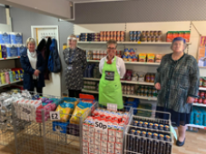
The key question was - How can we develop something that has a local impact for individuals, deal with future emergencies and be sustainable? Therefore, they took the social supermarket model and developed a social supermarket bespoke to the needs and wants of their local community. Shores offer their members a weekly shop at a fraction of what it would normally cost and in a social, positive, community setting. The money then helps provide stock for the store/food bank and 5% of the revenue goes into an emergency crisis pot that they can use. The Social Supermarket model allows Shores to refer clients from their food bank to their social supermarket to prevent dependency on the food bank and help enhance financial management skills. Since opening they have begun to see a decrease in the food bank members and an increase of social supermarket membership. It also prevents waste especially with fresh/chilled and frozen produce that they are unable to make use of at the foodbank. It has enabled access to healthier food options at a much lower cost. It has been more financially viable for organisations/businesses to redirect their food waste into social supermarkets and reduces landfill impact and costs. It has created access to an affordable broader range of products such as lifestyle essentials for personal hygiene and house hold cleanliness. It has helped remove the stigma of using a foodbank and welcomes the community as a whole.
“There was a need for a more community focused food project within our local community and if anything, the pandemic has highlighted the need for food systems to be more community-led, resilient and sustainable. The Social Supermarket has been a hub for the Withernsea community during these difficult times allowing access to affordable food, offering volunteering opportunities to local residents and preventing social isolation. They allow 3 emergency food parcels for individuals and families once they have been referred to the food bank and then allow them to take the next step to food security by having access to the social supermarket on a banding system. Band A – resident could be employed, no current receipt of benefits. Band B – universal credit pension etc attracts a 20% discount off the shelf price. Social Supermarkets enable empowerment for the individuals as they are making a financial contributing and have a degree of choice within food provision.”
Good practice (innovation)
- They have made very strong relationships with other food banks in the region and helped advise them with developing a similar model e.g., helping The Peoples Pantry and Two Rivers Community Pantry with the opening and planning of their Social Supermarkets in the Market Weighton and Goole areas.
- Shores have used this as a trading opportunity to generate income to invest into the food bank for food parcels if emergency helps is needed.
- They have developed an emergency response fund that gives them a safety net for future emergencies and crisis response. At the end of the financial year 5% of surpluses generated go into this fund.
- They have developed educational tools and community inclusion with our recipe idea cards called - take it, make it, eat it.
- Steps to Food Security model – this enables Shores to help clients move from food bank support and become more financially independent.
- They have developed something that is relevant in size to the community that they are serving, and they have let it organically grow.

Other examples in the database of literature include social supermarkets forming part of a mixed model called ‘Lewisham Homes’ Community Food Store; and similarly, a social supermarket adapted (see Saxena & Tornaghi, 2018) and incorporated into a mixed model found in the Foleshill Community Hub in Coventry. At its core lies the provisioning of access to good quality affordable food to people in the local community who meet vulnerability criteria in a retail like environment. This is backed up by a 'wraparound' support offer that includes, for example, debt and welfare advice, employment support, training and reskilling, and broader support for health and wellbeing. People have access to the CSS on a membership basis, reviewed at six monthly intervals. Opening hours have shifted with demand since 2020 to meet community needs.

6.2.2 Food pantries


Food pantries are planned and delivered by local organisations - the RSLs, churches, charities – and focus on “priority neighbourhoods”. Each pantry is managed by a multi-agency/multi-stakeholder board (which includes also volunteers and members) to oversee and coordinate the operation of the pantries in its area.
There is not a single model of food pantries; there are membership and non-membership models. Pantries comes in different forms: a) Membership based pantries which are part of network of “Your Local Pantry”, which is a social franchise run by partnership between the Skylight and Church Action on Poverty and Storehouse pantry. The membership-based pantries operate like cooperatives with subscription fee paid weekly (£3 - £5, set the by the pantries) in return for choice of groceries (10 items) worth more several times the subscription fees. b). Non-membership-based pantries (e.g., Sharehouse, Foodworks shared market, Neo community). These pantries provide access to food surplus on ‘pay-as-you-feel’ approach. The users/customers are invited to pay in money, time, or skills. The underlying principle is that of “inclusivity”. The fact that they receive food as donations or that they intercept the food makes it possible that the food is not priced.
‘The model is different from a food bank in several important ways, in that is a membership food shop, focused on a particular neighbourhood. Pantries enhance communities and are a preventative approach to food poverty, reducing the risk of household hunger.’ (Dr Megan Blake, University of Sheffield, 2022 also credited with the content below)

Access and eligibility
- Membership based pantries - access is controlled through membership subscription and geographical location. Although, there are no time limit on length membership and depends on the individual needs; membership is opened only to members of the community / neighbourhood within a specific postcode (in “priority neighbourhoods” according to the government’s indices of multiple deprivation and/or have been referred by a partner agency and meet certain “light touch criteria” of need around whether prospective members are struggling with energy bills or rental payments, or multiple debts or any kind of financial issue that they need help with). Although psychological barrier – stigma is somewhat reduced through the membership fees. However, the membership subscription can act as a financial barrier. As studies in in the context of food banks have shown that when ‘membership’ is means-tested, there is a degree of embarrassment or stigma attached to participation and membership can lead to creation of a two-tier society – while including some, it also excludes others who may not it into the membership criteria, but equally experience lack of means to access food. Non-membership-based pantries: Access is open to all irrespective of economic status, and prices are pay as you feel basis. The choice of maintaining the premises open to everyone is described as ‘inclusive’. There is no exclusion based on geographical or socio-economic conditions which also necessitates looking into people’s personal conditions or life choices.

Access to food/amount of food
Pantries offer food access to people who were not in crisis, but still vulnerable to food insecurity.
- In membership-based pantries access to food is controlled in the pantries using color-coded categories depending on the demand and to ensure a fair distribution. During each visit, a member/user can only take a certain number of goods from each of the different categories (1 red; 2 blues; 3 greens and 4 yellows - to ensure a balance of fresh, packaged, and higher value foods).
- Non-membership based models operate differently based on the location and set structure. In some pantries like Sharehouse, in one part of the store, food is offered on a pay-as-you-feel basis and users are allowed to take as much as they need, and in another part, volunteers serve the more limited items at a cost of £1 for a basket. However, there is a general restriction in place in terms of two bags of food per person on grounds of fairness.

Examples
Bradford: Inn Churches, a third sector organisation that provides practical support to people in Bradford including a Food Hub, established the ‘Food Savers’ scheme with the rationale that they did not want the legacy of COVID-19 to be an overdependence on free food. Members of the scheme access the low-cost food markets whilst also establishing a savings account through the Credit Union:
“In addition to the pantry model, one thing that’s developing in Bradford, and it's beginning to spread as well, is our FoodSavers Network, where the local Credit Union has got on board, as well. That has actually really turned lots of people's lives around that they've actually started saving a few pounds. They're purchasing their food at low cost and they're putting a pound a week aside or something. Then, for some people, that has really shifted their thinking. We’ve found that lots of people have been really positive. We've been surprised that people… We were worried that people would resent having to put some money in, but then some people have really found that a positive thing and actually have started to take charge of their life in a way they never had before, which is really, really positive.” (Partnership workshop, Bradford) This model was also something that was being considered in Leeds.
Beverley in the East Riding
"Thank you to everyone involved in the Beverley Cherry Tree Community Pantry. We are benefitting from it so much, it helps ease money worries but more than that we're cooking more together, meal planning and eating healthier foods. Thank you all very much. (Anonymous Client, Beverley Cherry Tree Community Centre)"
Three case studies are found in a 2020 study that explore the characteristics of each pantry model in terms of their charity status, whether they were rural or urban, deprivation ‘level’ in the locality, the services provided, and the type of beneficiaries involved.
- The Core Project; Urban; Very High deprivation; Community Café, Food Pantry; involving homeless people, people who are socially excluded, single parents, older people, people with mental health problems
- Edlington Community Organisation; Rural; Very High deprivation; Food Pantry, Emergency food parcels, shared meals; involving single parents, people with mental and physical health problems, older people
- Multi-Denominational Centre; Urban; Medium derivation; Food Pantry, a shared meal; involving socially excluded people, people with mental health problems

North Craven Food Pantries
Age UK North Craven has been supporting three food pantries in Bentham, Hellifield and Ingleton (North Yorkshire) since 2020, and as part of a wider COVID response that saw the development of the Craven Food Partnership. New pantries have since developed in Settle, and the pantries form part of a network of food access / support provision across the locality – including fridges, food banks, a local Quakers that does cook ups using food before it goes to waste and allotment groups. The Pantries evolved out of a social purpose rather than an environmental / food waste ambition, and are faith-based (multi-denominational), managed by volunteers and reliant on donations which brings challenges. Age UK North Craven, in its role as a locally trusted organisation, using its ability to secure grants from diverse sources has been able to help ensure the pantries receive an adequate supply of food, including fruit and vegetables which would otherwise not come through supermarket or other donations. Cost of Living means that donations of this nature from supermarkets are rare because those goods are being sold in their stores more cheaply.
The pantries originally labelled themselves as ‘pop up pantries;, but there has been a realisation that they are in fact community pantries and will need to continue to meet local needs and poverty. The models have traditionally been ‘bring what you can, take what you need’, however, in an attempt to improve sustainability one of the pantries is evolving into a social supermarket (Bentham). This despite being one of the pantries that does well for donations of food and money. It is also the pantry receiving the greatest footfall and people in need. A £2 contribution gives access to 3 bags of shopping. Before deciding to evolve, Management Group representatives and volunteers visited models in Hexham and Carlisle to learn the merits and pitfalls. The model is in its early days, but it is seeking to demonstrate that such a model can exist in a more rural location where many appear to be urban-centric.
A particularly helpful intervention using grants from the Stronger Communities Programme was to train volunteers at the pantry in how to have difficult conversation known as ‘Conversations for Change training’. This enables participants to develop a sound introduction and grounding in the communication technique of Motivational Interviewing. This kind of capacity building alongside a desire to help people using the pantries / social supermarket progress away from being insecure to better outcomes (e.g., accessing advice or getting a job) is helping to further evolve the model for the future whilst other options beyond grants are being considered for income generation and viability.
Strengths and limitations of food pantries
These 3 case studies and the wider review of literature offer useful learning about the efficacy of these different food pantry models:
Food pantries do create opportunities for people to come together and a focus for conversations are particularly effective for helping to cement social ties. However, activities that take longer i.e., cooking meals / cooking activities are seen as being more effective for creating relationships. The pantry model can help families and children to connect by using some of the food surplus for activities such as cooking / learning together. Members feel more connected to their local community through the pantry and there was evidence that members made new friends with knock-on positive effects to their mental and physical health. Some have used the pantry as a way of meeting others, feeling more connected to their community and making friends which has been good for reducing feelings of loneliness.

Food from the pantry gets people in the door, this often leads to participation in other activities. For example, some started out coming to the social supermarket and now come to the older people’s bingo too. (This was an example piece)

Pantries offer short-term emergency support. Being a member of a pantry improves household finances. A typical food basket is valued at £20 saving members at least £15. Pantries can allow families some flexibility with other shopping needs. It can be very beneficial for example to those in need of fresh meat and halal. With money saved from the pantry use – Christmas and birthdays and meals and carpets have all been references to being financed rather than using a moneylender etc. some have used savings to fund a particular activity i.e., membership to a football or swimming club for children or days out that they family would not have been able to afford ordinarily. The case studies suggest that using a food pantry can help reduce stress, new foods are tried, and members cook more creatively. Members consume less processed food through use of the pantry and more fresh fruit and vegetables are consumed. An issue was raised around how people come to a pantry but don’t go to put their food away / in fridges / freezers straight away as they likely would if they had been to a supermarket and how pantries wanted to make it feel more like a shopping experience which would help normalise the trip and using surplus food as shopping.

Challenges/limitations faced by providers:
- High dependence on establishing and sustaining relationships with food industry suppliers to ensure continuous provision of food. Issues of trust, cooperation and reliability are seen as critical when working with multiple stakeholders.
- Logistic and distribution challenges – investments in infrastructural – transportation, storage facilities (storage space and storage infrastructure (i.e., shelving), and having enough volunteers to deal with coordinating activities. The short of shelf life of the products requires timely sharing of information, especially dealing with diverse supply sources. While sourcing food from national redistributor like Fareshare improves logistical challenges, it can result in ‘organisational food losses and waste’ due to short shelf life. Direct donations by supermarkets to pantries will reduce losses and waste
- Unreliability of surplus food – pantries dependent on food surplus except for a small amount of fresh produce which is donated by food growers. The unpredictability of volume and nature of products of food surplus on one hand and control over stock to meet demand is a challenge, especially for pantries sourcing diverse sources.
- Availability and coordination of volunteers – unavailability of core volunteers particularly during summer holidays and lack of expertise of volunteers provide challenge for organisations
- Financial challenges – pantries generate income mainly through membership fees to cover cost of personnel, rent and operating cost as well as the services provided; there is high dependence on private and public donations and funds/grants to meet overheads costs - rent and/or infrastructure are considered as the major costs in the running of the pantries.
- Pantries can have excess produce that it struggles to eat or sell in certain seasons; and needs transport options to be able to deliver or offer food to other organisations to use.

Lived experience insights
‘It has made me feel less of a failure for not being able to provide the basics that we need.’

Pantries can be for people in food crisis who need emergency food support; people who are just about managing, but not quite. Members come from all kinds of household types from multigenerational families to single elderly people, families and single parent households. Children, families, older people aged 65 or older, living alone, white, black, other ethnicities etc. For members it is important that: there is increased fresh and healthy food available to them, making friends, tackling food waste, choosing their own food and reducing cost of bills for food. Tackling food waste is important to members of food pantries and is therefore a key benefit to communicate about this model.

Learning for the future and changing practice to be more effective
‘The traditional food pantry model fails to recognize the influence of self-efficacy on a person’s food security. A food pantry model with client-choice, motivational interviewing and targeted referral services can increase self-efficacy of clients. Prioritizing the self-efficacy of clients over the efficiency of pantry operations is required to increase food security among disadvantaged populations.’
‘Food bank directors and food pantry staff are increasingly looking for ways to address the underlying issues of poverty rather than only give away food.’
‘Lots of volunteer hours are dedicated to the running of a food pantry.’

6.2.3 Community shops/stores

The Community Stores/Shops are part of the Company Shop group. Community Shop describes itself as an award-winning social enterprise and the UK’s first social supermarket. It claims to be the UK’s leading redistributor of surplus food and household products and there are currently 14 Community Shops in operation – see Our Company Shop locations | The Company Shop Group. It was founded in 2013 by Company Shop Group (CSG) with a mission to build stronger individuals and more confident communities. It asserts that it achieves this by combining heavily discounted supermarket goods with a range of social services and activities, in order to help people escape food poverty and realise wider success in their lives. It is in fact a mixed model comprising three elements: 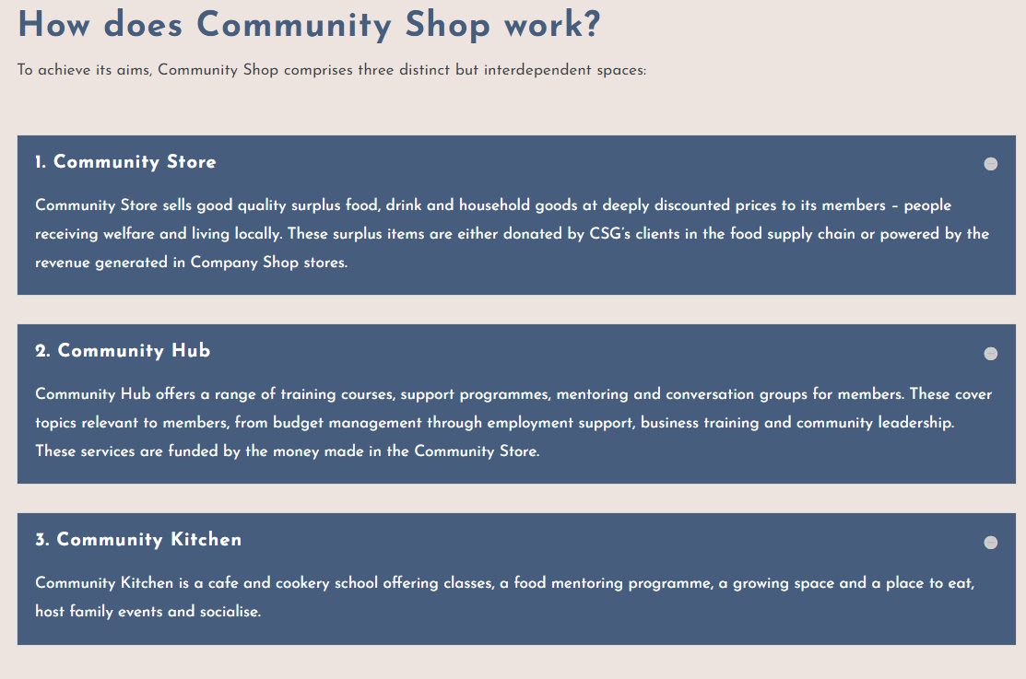

It provides members with vital access to deeply discounted food, as well as learning and development programmes. The community kitchen offers hot meals to members and their families at lower price. As part of the community store, there is community hub that provide host of services to members to tackle the root causes of food insecurity.
Access and eligibility
Closed access through membership which is based on three criteria: a) people who live locally in a specific local postcode area chosen in line with the government indices of deprivation; b) people living in a household that receives some form of welfare support; c) and those who are motivated to make positive changes in their lives, and want to sign up to their ‘Success Plan’ which involves individually tailored professional and personal development programmes. The membership runs initially for 6 months and undergoes periodic reviews. While the membership criteria provide targeted approach to tackle food insecurity and those struggling, it potential excludes other members of the community who may be experience moderate food security but not receiving social support.
Access to food/amount of food
Members have access to heavily discounted food and household products up to 70% off the normal retail price, helping to stretch family budgets further. There is no restriction on the amount of food items or households’ essentials that members can buy. However, there is restriction on the amount that can be purchased at one time by a member (any 6 of 1 identical item per day).
Outcomes
Benefits to members
- Improves food and nutrition security: With community shops located in areas lying within the 10-20% most deprived neighbourhoods in the UK – areas with limited access to mainstream shops, limited access to fresh fruit and vegetables, and multiple health issues. The community shops improve food and nutrition security. With daily access to available healthy foods, 85% members have reported eating heathier – eating more fruits and vegetables since joining the scheme. The cooking classes and food awareness education aspect of the scheme increases members food knowledge and literacy, and they are better educated to eat healthy at home and to try new food.

The integrated food hub of community shop, community hub and community kitchen provide stability to those members to improve their food security long-term. However, the membership criteria exclude people who may be experience moderate food insecurity but are not benefits.

- Improves Wellbeing: paying for the food makes members feel more confidence in themselves which improves their self-worth and feels less stigmatised. The opportunities for members to volunteer at the shop, kitchen and community hub boost members confidence and provide valuable employable skills. For example, in 2021 alone 187 members volunteered or completed work placements with the community hub and 7471 people received support through the community hub programmes. However, non-members cannot volunteer therefore excluding potential people who may not want to sign to the personal development programmes.

- Health outcomes: Being a member of the community shop improves mental health and reduce anxiety – members do not have to worry about stretching their budget to buy good quality food - reduces financial worries of what they put on the table and allows time to think about their ambitions and their future. Coming to the community shop/kitchen or volunteering improves members physical and social wellbeing.
- Improves household income: On average, members save of £212 each month on their shopping bill, thereby increases financial wellbeing. Users can buy more wider range of good quality food than would be able to buy if they shopped in supermarkets or local corner shops

Community outcomes
- Community resilience and social infrastructure. The community hub provides advice and activities to members while the community kitchen that service hot meals at lower prices for the members provide good space for members of the community to make new friends and build social networks -thus improving their social interaction and helped them tackled isolation. The seasonal activities for families and kids help build family bonds and friendship, increase sense of community and belonging.
- Investing in community. The revenue raised from the in-store sales is invested in the Community Hub, where members can gain access to personal development support, with sessions including everything from cook clubs and home budgeting, to interview skills and business courses and community leadership training.
- Connecting with community services /strengthening communities. Members who participate in the community hub activities are connected to other support organisations in the communities thereby providing them with opportunity to build back their life.

The Relationships Project has developed a case study about the model detailing the following kinds of outcomes for people using Community Shop/Stores.
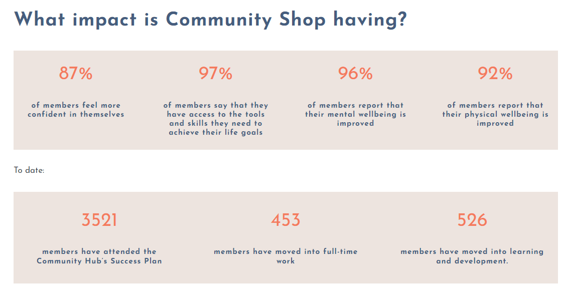
Example
The case study goes on to suggest that in practice Community Shop warmly welcomes people looking for support in all sorts of unexpected ways. One member, Jenny, tells the story of Community Shop helping her find a job.
“I was buzzing as I came back to tell everyone that I had got a job, to start the following Monday, but then panic hit again as I realised I couldn’t afford new work clothes and safety footwear. The Community Leaders rallied round and sorted me out quickly.”
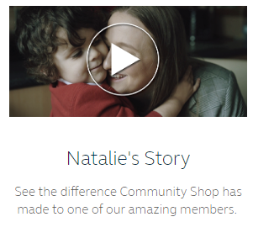
Natalie’s story hears how she learned about Community Shop by accident and that she’d heard it provided food cheap and at a reasonable price for people on Universal Credit. But her journey, starting with food, has led to her doing some Kickstart classes and a decision and pathway to college in a very short period of time. “A fresh start that I never thought I would have.”

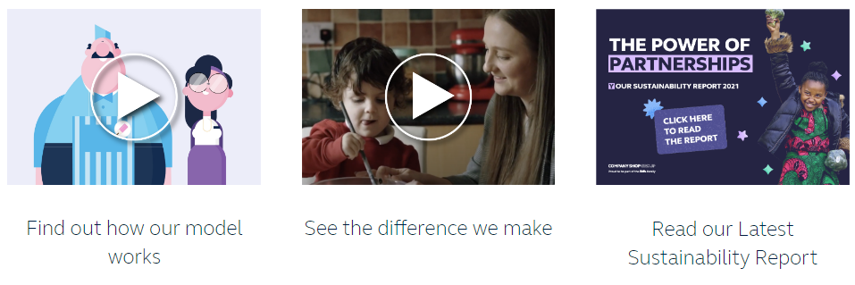
The Relationships Project case study asserts that ‘Community Shop is more sustainable than many other social supermarkets, largely because of its commercial arm, Company Shop, and overall Group heritage and structure which helps avoid supply-chain and staffing issues.. More insight about the model and how it works is found here About Us | The Company Shop Group

Good practice
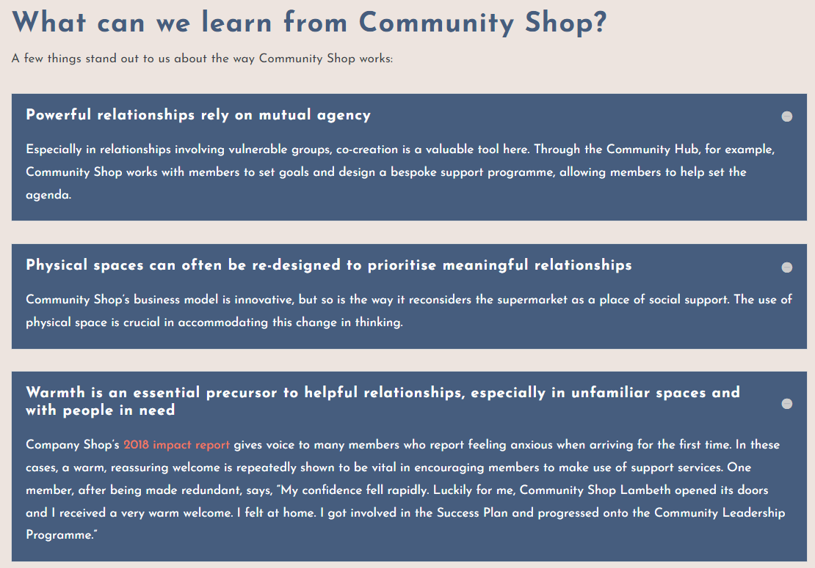
Models like Community Shop represent an interesting body of research exploring the social possibilities of using food as a powerful tool to bring stronger individuals and more confident communities. DEMOS think-tank Demos released a report in 2015 exploring social supermarkets as a sustainable solution to food poverty.
The case for low cost community food retail?
The model offers affordable, accessible and typically more nutritious options that could be regarded as a next step from needing to use a food bank. The model encourages more dignity because a contribution is made and there is choice. Models can often be mixed which gives rise to wider individual and community benefits aligned with their social purpose. The models enable revenues to flow that can then be re-invested into the wider social purpose in that community.
Questions arising
- Can the evidence be strengthened to the point where a food pantry / social supermarket / community shop is knowingly able to address the root causes of food insecurity, and help clients achieve long-term food security and self-sufficiency?
- How could the reciprocity aspect of low cost community food retail be embedded across all or more of the food models made available in communities, as this seems to amplify feelings of dignity, reduce stigma and encourage use without people feeling different.
- How could these models operate / be adapted for rural or sparse communities?

Local responses to household food insecurity across the UK during COVID-19 (September 2020 September 2021). An analysis of experiences from 14 local areas from around the UK and recommendations for future policy and practice p17
ibid
ibid
Community social supermarkets: understanding how they shape access and availability to healthier foods in food insecure communities, 2022, School of Health & Life Sciences Teesside University with NIHR (applied research collaboration North East and North Cumbria)
This study will be led by the School of Health & Life Sciences Teesside University with NIHR (applied research collaboration North East and North Cumbria)
Dr Blake drew on these sources for her synthesis kindly supplied to the research team for this study: Maynard and Tweedie, 2021; Lambie-Mumford, 2014; Lasko-Skinner and Jeyabraba, 2021; Saxena and Tornaghi, 2018; Psarikidou et al., 2019; Jenkins et al., 2021
For example, in Grangetown, Redcar and Cleveland New Next Step Shop opens in Grangetown Community Hub - footprintsinthecommunity.co.uk
Food Insecurity: Understanding local delivery, impact and innovation in the North East Riding (2021)
https://innchurches.co.uk/foodsavers/
East Riding Food Poverty Project Alliance Report. 2021
Releasing social value from surplus food Evaluation Final Report FareShare-British Red Cross. Impact of British Red Cross funding on FareShare to tackle Loneliness and Isolation. February 2020
Conversations for Change - RIPEN (ripens.co.uk)
Community Shop - Relationships Project

