6.9 Other resources for food response

This model of support is directly inspired by this report: ‘Local responses to household food insecurity across the UK during COVID-19 (September 2020 September 2021). An analysis of experiences from 14 local areas from around the UK and recommendations for future policy and practice.’ This report highlights funding, food supplies and human resources were key resources for ensuring a food response during the pandemic. The report suggests that:
In York and North Yorkshire, both local authorities worked alongside the voluntary and community sector, health partners, local communities, mutual aids, faith organisations, businesses and many other grassroots networks and contributors to mobilise a response to the pandemic, particularly to support the most vulnerable residents.
This chapter focuses on just one part of that wider effort, namely, the deployment of Defra, and then additional NYCC resources, to provide food access and support in North Yorkshire. Our thanks to the Stronger Communities Programme for providing these insights in October 2022.
Food banks and community Food Projects’ (Defra Rounds 1 and 2 and ‘Food for the Future’ funding Programmes.
- Number of Projects funded 2020 – 2022: 68 Projects
- Number of Providers delivering 2020 – 2022: 41 individual providers
- £ investment over time period 2020 – 2022: £365,861 spent
- Core programme outcomes
Defra R1 & R2: Supporting and expanding the direct provision of food for those people and families experiencing financial hardship and offer additional support i.e. signposting for access to longer term help.
Food for the Future: Increased partnership working, with a focus on provision of sustainable food options for those in need, whilst supporting people to improve their confidence and increase independence.
Grant awards were allocated to support and expand the direct provision of food for those people and families experiencing financial hardship with the core aims of:
- Providing food supplies to those in need due to financial hardship
- Providing additional support, for example, signposting people to advice and information to help them access longer term help such as benefits advice or emotional wellbeing support

In 2021, the funding shifted emphasis with a new name ‘Food For the Future’ (FFTF) which provided grants with these core aims:
- Provision of a sustainable local food option to those in need
- Supporting people to improve their confidence and increase their independence
- Partnership working with others, for example with other food bank and / or community food support projects in an area, statutory services and local businesses.

Commissioner thinking was that as we move out of emergency response and look towards recovery, there is a need to explore how the new and emerging local food support options can be retained and / or developed in a sustainable way on a longer term basis; whilst supporting people to improve their confidence and increase their levels of independence.
Projects receiving FFTF funding were encouraged to demonstrate how their approach / project would demonstrate they would contribute to at least one of the following outcomes:
Outcome 1: Reduced Inequalities
- Reduced health inequalities.
- Improved access to services and / or activities.
- Increased levels of independence and confidence for those accessing services and / or activities.
- Reduce risk factors, including poor nutrition.
- Increased levels of trust, choice and control (individuals and communities).

Outcome 2: Improved Social Connectedness
- Reduced loneliness and isolation.
- Reduced stigma in relation to accessing food support options.
- Improved individual and community health and wellbeing (emotional, physical and social).
- Increased community resilience.
- Increased levels employment, skills and / or volunteering.

Outcome 3: Improved Wellbeing
- Improved emotional, physical and social wellbeing.

Priority would also be given to the following applications:
- Projects that demonstrate a clear commitment to a strengths based approach and promote partnership, collaboration or networking across existing provision – for example, working with other key voluntary organisations, statutory services, or collaborating with local businesses.
- Projects that address identified unmet needs or demand and / or fill gaps in existing provision.
- Projects that can demonstrate that further to Food for the Future investment, the project can be sustained on a longer-term basis. This could achieved be through the creation of reasonable charged-for-services or embedding educational or training elements in to the project.
- Projects that are inclusive and equitable, as well as flexible and adaptable - for example, able to adapt to varying levels of Covid19 restrictions as required or fluctuations in demand.
- Projects that are rooted in social action, and value the inclusion of volunteers in their delivery model.

Investment enabled VCSEs / food providers to develop capacity, capability, invest in HR resource, equipment, storage, volunteer support, buy food, deliver services to communities in these ways:
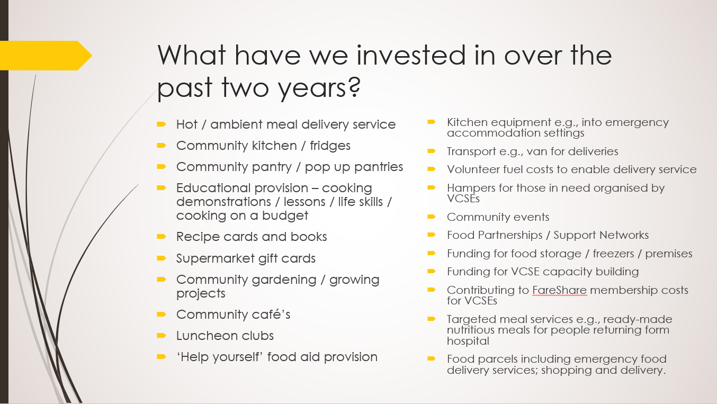
Each project / provider awarded a grant was encouraged to complete proportionate monitoring and evaluation. Data analysed from providers in receipt of the two rounds of Defra funding identified a range of outcomes for individuals, communities and their own organisation. These outcomes are presented on the following pages and further work is currently being completed to understand the effects of the Food for the Future programme as evaluation forms are returned.
This section is provided to stimulate discussion amongst local authorities and other funders who may also have invested in food response through funding / grants, and / or providing HR and resources to enable the purchase / supply / redistribution of food surplus in communities. In addition to this snapshot, there are other central and local government resources being used to support food response including local welfare assistance programmes and the Household Support Fund and from Foundations there are a range of cost of living related funds in place that ultimately can support food access.

As a result of the funding projects reported these outcomes for residents / individuals supported by their activity:
- Older residents felt empowered to share food related experiences
- Volunteers have felt purposeful and useful (particularly in the pandemic heights – wellbeing increased reported)
- Increased levels of trust, choice and control
- Better able to engage in other services
- Felt assisted in the prevention of returns / admission to hospital
- Improved emotional, physical and social wellbeing
- Improved meal making skills – ability to chop, slice and cook fresh food items that they previously would have discarded.
- Encouraged to leave house / get out more after a long period of being told to stay indoors
- Specific groceries have been received for those needing a bespoke service
- Received genuine and tangible support when they needed it most.
- Some have started volunteering themselves who were being supported by the organisations / projects
- Reduced isolation and loneliness, particularly in those that may have felt they’d lost their purpose through losing their job, being on furlough, retirement etc.
- More individuals have had access to food at a time of need
- Improved employability (volunteers)
- More individuals supported sooner due to home visits / conversations that were fed back to befriender (or similar)
- Helped improve people’s confidence to socialise
- Stigma has been reduced through inclusion of social activities
- Increased confidence and independence
- Increased confidence in trying new foods and broadening tastes.

As a result of the funding projects reported these outcomes for communities supported by their activity:
- Welcoming and supportive environments were created for clients to socialise and/or request assistance
- Increased levels of trust, choice and control created
- Projects helped alleviate the strain on the family budget
- Reduced stigma in relation to accessing food support options
- Project brought communities together as well as several other charitable organisations either by support or signposting to the right support
- Courses, have enabled inspiration and increased skills for individuals / families to cook and grow food from scratch
- There has been measured reduced food waste for example: ‘We have been able to collect vast amounts of surplus food from supermarkets and other sources and have saved at times over 100kg a day of food from being wasted.’
- Reduced loneliness and isolation in community, through provision of friendly, central spaces to talk to others locally
- Reduced the risk of poor nutrition by providing supervised cooking lessons and access to cookbooks and recipes designed for eating healthily on a very limited budget
- Enabled independent learning and skill development
- Development of a Cash First Leaflet, and similar signposting documents and information that direct people to appropriate sources of support especially around debt and finances. (Increased knowledge of local provision and made accessible)
- Brand new services in communities, for example: a new Pop up Pantry in Settle.
- Potential reduced admission to hospital for example: ‘‘Food First’ that was designed to meet the needs of people in poor mental and/or physical health and/or financial hardship has supported vulnerable people at this extremely difficult time, who, without nourishing food may have been admitted to hospital’
- Or enhanced provision for example: ‘It has allowed Hellifield to extend the range of activities on offer, so that regular social activities and exercise groups are now meeting and for Ingleton to offer coffee and chat alongside the Pantry offer.’

As a result of the funding projects reported these outcomes for their own organisations:
- Increased resource to tackle demand i.e. recruitment of a Food Project Development Officer which has allowed organisations to allocate the time required to do in-depth work with clients that they might not have been able to if not for this funding support
- Enabled links to be developed more formally with statutory authorities
- Better able to identify areas of risk and need and individuals in most need of support
- Confidence to apply for funding for a similar project / thematic ‘purpose’
- Increased knowledge of crisis, and circumstance, partners and the local picture through attending forums, partnership meetings etc.
- Running more effective services
- Approaching self-sustainability through a combination of members contributions, grant support and local donations.
- Reduced financial strain on small charitable organisations.
- Increased the number of areas covered as an organisation.
- Projects have helped facilitate closer cross-partnership working which has allowed support to be mobilised more quickly and effectively.
- Funding has helped develop organisational resilience.
- Funding allowed organisations to establish themselves as a trusted organisation where people feel safe and secure communicating difficulties with and trying new activities.
- Local businesses and organisations have had the opportunity to work together.
- Increase in profile in the community leading to further referrals and, further funding from local businesses.
- Increased reach of those who would not have attended larger community events through lack of confidence or awareness
- Funding has allowed for target deliveries to meet specific family needs which were not so feasible prior the Programme
- Become a contact point on a weekly basis for emotional wellbeing support in the community
- Organisations have realised their wealth of knowledge on nutrition, growing food and crafts for example. This has inspired some to think how they could run a similar course in future whereas this was not a priority / organisational focus previously perhaps.
Challenges
The national report cited at the start of this chapter highlighted a range of challenges to consider around funding and resources for food support including, but not limited to:-
- The shift from an ‘abundance of funding from March to August 2020’ to a situation where funding was less available, and in the interim period, food initiatives set up to respond to the pandemic had ceased to operate – whilst demand was still high in communities for support owing to increased levels of hardship across the general population
- Increased levels of dependency and reliance on services during the pandemic – without those services necessarily being available to the same extent moving towards recovery
- The stipulations and conditions attached to funding for third sector organisations was variable amongst those providing this kind of resource, impacting food aid providers in different ways. In one of the case studies (Herefordshire), a food bank organisation noted that two local authorities of the areas they covered provided direct grants to the food banks, for infrastructure type of funding and some grants for food and vouchers type of funding. The other authority encouraged the food banks to expand and move into debt advice, provision which stretched them further.
- The capacity of small organisations, completely run by volunteers, to apply for funding is very limited so in the absence of that capacity their reliance on local communities is huge and if that community is ‘well-heeled, its’ easier to expect donations, but in some areas that’s much more challenging.
- Keeping the bureaucracy associated with funding / grants to a minimum but within the confines of audit (Source: Council workshop, Belfast)
- More generally, there were challenges at the start of the pandemic and now being echoed as a result of the cost of living crisis in the disruption to food supplies and reduced donations (cash and food / nutritious food especially which is being sold more cheaply in supermarkets). Using surplus food attracts concerns about the quality, quantity and suitability of food sourced this way with research participants saying there needed to be a move away from dependence on food surplus. This was a divergent opinion, however, and others recognised the valuable source of food that this surplus provides the third sector. The language of ‘food waste’ seen as being ‘leftovers’ and attracting negative connotations was problematic and ‘food surplus’ seen to be a more positive framing.
- The human resource dynamics for food response were many during the pandemic and revolved around the availability of a volunteer workforce to support emergency response; and to maintain support as people who had been furloughed returned to work – this brought challenges in terms of induction, safeguarding, proportionate bureaucracy to bring new volunteers in at a time of urgent crisis, training, support and dynamic policy and practices.
- More recent insights gathered in North Yorkshire amongst a small sample of food aid providers points to the concerns with the increased energy costs if they have a premises, in which they have a kitchen / ovens / freezers / fridges to maintain as part of their operating model to support people experiencing food insecurity.

Opportunities
- Mixed models of funding for the future: For some food providers they felt the pandemic had brought food aid to the forefront of people’s attention and this had opened up a wider range of funding options including private investment, from companies and universities (source: Edinburgh charitable food aid workshop)
- The opportunity to continue having ‘food conversations’ and food funding conversations beyond the experiences of COVID winter grants and Household Support Fund or other central government sources as they are announced
- Different parts of the system working together to support people back to independence rather than continually supplying a food parcel (Source: Council workshop, Leeds)
- New means of sourcing food in practice or in planning e.g. a Leeds food bank (Trussell Trust) has been supporting lots of the independent food providers working together on food supply / distribution / reach into communities
- A scheme where the local authority purchases food (so that it’s ‘cheaper than Aldi or Lidl) and distributes it via a pantry model, but not surplus food (Leeds are looking at this)
- Exploring collective purchasing e.g., memberships across a collective of VCSEs / food aid providers in a whole place where this might be appreciated
- New actors are now operating in the field of food aid which is opportune in so far as this could provide more channels to reach more people in communities; at the same time, this becomes problematic if they are either a) not connected into local networks of similar food aid / motivated providers and funders or b) if their provision isn’t actually reaching the people who are very or most food insecure.
- Sharing or transferring resources in communities - We have come across examples where in some localities fridges previously run by one food aid provider became too expensive have successfully been handed over to another asset in the community to operate as a community fridge, with motivated volunteers working hard to cover these costs and provide a supply of food through that model and equipment.

Questions arising
1: For any future funding (by local authorities), what would be an appropriate mix of grants to achieve desired outcomes (and which ones?) whilst encouraging resilience rather than dependence?
2: How can funders make fair decisions when faced, almost inevitably during the foreseeable period owing to the cost of living crisis, with heavily oversubscribed applications whether for grants of other commissioning approaches, mindful of:
- Local context
- Extent and type of need
- Population focus (e.g. ‘vulnerable’, households with pensioners, children, people with a disability or other characteristics determined)
- The need to ensure equity if managing a place-based portfolio i.e. spread across localities
- Specific challenges and additional costs to deliver / meet needs in rural / sparse areas
- Encourage collaborative behaviours in localities serving the same community where models can complement one another
- Build on any previous funding awards for the same organisation if the intention is to support the evolution of their food support
- The key purpose of any funding or investment e.g. direct food provision or resources for essential items and / or infrastructure support with an eye to the future
- Whether these are other better / alternative funding options and alternatives for providers to meet their communities’ needs during the same time period
- Whether it is important to weight / favour / approve grants for a) new providers / actors in the market or b) prioritise mature / established models or c) build collective approaches whether new or established or developing towards a set of common outcomes
- The reach of any proposed food provision/ support/local project
- The added value by funding something that is located in a wider hub / wrap around model where people not only get food but can have wider needs identified or met
- Value for money
- Evidence that any proposal has an eye to sustainability

Here are some scoring criteria applied to recent food-related grant applications. Score of 5= eligible, 3 = marginal, 0= ineligible (no further evaluation needed).
- Eligible expenditure under food bank and provision criteria / scheme criteria
(including meeting both aims of the fund, meeting at least one outcome described in the guidance and meeting priority criteria)
- There is a clear, identified and well evidenced need for the project.
- Anticipated numbers of beneficiaries identified
- The project is financially viable.
- Volunteers and/or community partner involvement
- The organisation/project has appropriate monitoring processes in place to enable external validation.

3: What % of any funding should be apportioned to encourage solutions aligned to the food ladders strategy model a) catching b) capacity building c) self-organising?

Progression model and /or investing for community abundance?
4: Some strategies recommend a cornerstone approach of moving an individual progressively from food banks to pantries to social supermarkets to supermarkets, essentially a movement from being very food insecure to stability. Alternative thought leaders, as for example suggested in the ‘The Food Ladders Project - Mapping the Geographies of Food Provision in Sheffield’ (2022) study found that:
‘Many of the organisations interviewed shared a collective dream of a network of community food spaces in the city. These are cafes to provide a hot drink and meal, but also social supermarkets where anyone can get access to fresh, low cost food. The aim of these spaces is not progression to mainstream commercial provision (i.e. from foodbanks to Supermarkets) but is instead more investment in the community itself. We must move thinking towards a new narrative of abundance in which people don't use services, but are instead part of communities that provide them. Our recommendations set out to make this dream reality.’

