**Food insecurity Definition: ‘*When a person is without reliable access to enough affordable, nutritious, healthy food’ (British Red Cross, August 2023)***

**Factors impacting on food insecurity** (HoCL, Food poverty: Households, food banks and free school meals, August 2023)

* Food inflation March 2023 was 19.1%, the highest since 1977. In July 2023, food inflation was 14.8%.
* Food inflation on own-label budget ranges was 24.3% in July 2023 for branded goods it was 12.2%.
* In July/Aug 2023, 56% of adults reported an increase in their cost of living compared with the month before (ONS). Of these, 47% had started spending less on essentials including food.
* In 2021/22, 4.7 million people in the UK (7%) were in food insecure households in the UK (DWP). This included 12% of children, 7% of working-age adults, and 1% of pensioners.
* In June 2023, 17.0% of households in the UK were ‘food insecure’ (ate less or went a day without eating because they couldn’t access or afford food), from 8.8% in Jan’22 and 7.4% in Jan’21. The Food Foundation.
* Over 760,000 people used a Trussell Trust food bank for the first time in 22/23, a 38% increase from 21/22.

**UK local food insecurity of adults 2021** Estimates by Dr Angelo Moretti (MMU), Dr Adam Whitworth (Univ Sheffield) and Dr Megan Blake (Univ Sheffield).

|  |  |  |
| --- | --- | --- |
|  | Household estimates | Highest |
| Hungry: having skipped food for a whole day or more in the previous month or indicated they were hungry but not eaten because they could not afford or get access to food | York 2.81% = 2,458  North Yorkshire 5.0% = 13,692 | Selby (7.84%),  Craven (6.07%)  Scarborough (5.64%) |
| Struggle: a positive response to at least one of the following:   * Sought Help accessing food * Skipped or shrank meal * Gave a reason for not having enough food | York 7.54% = 6,601  North Yorkshire 10.4% = 28,681 | Selby (14.7%)  Scarborough (11.36%)  Craven (10.08%) |
| Worry: choosing very worried or fairly worried about getting food | York 9.5% = 8,315  North Yorkshire 8.1% = 22,240 | York (9.50%)  Scarborough (9.44%) |

*Please note: these percentages are not additive across measures. These are estimates only – confidence levels provide lower and higher estimates.*

**Food vulnerability index (June 2020)**

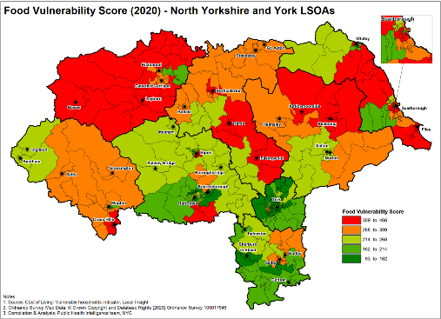Food vulnerability index combines: Frailty, Living alone, Distance to services, Digital exclusion, Income deprivation, Benefits data ,Asylum seekers data.

Areas as rated most highly:

***North Yorkshire***: Filey, Weaponness & Ramshill, Falsgrave & Stepney, Northallerton South, Woodlands, Upper Dales, Northallerton North & Brompton, Romanby , Sowerby & Topcliffe, Pickering, Leyburn & Middleham

***York:*** Westfield, Chapelfields and Foxwood

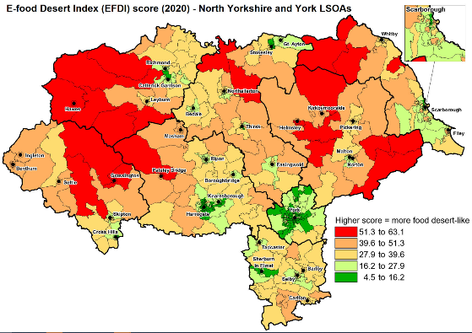

© Crown Copyright and Database Rights [2023] Ordnance Survey 100017946

**E-food desert index (2020)**

The e-food deserts index uses four key drivers of groceries accessibility: (1) Proximity and density of grocery retail facilities, (2) Transport and accessibility, (3) Neighbourhood socio-economic and demographic characteristics and (4) E-commerce availability and propensity.

Areas with most limited access:

***North Yorkshire***: Upper Dales, Hunmanby & Sherburn, Helmsley & Sinnington, Wharfedale

© Crown Copyright and Database Rights [2023] Ordnance Survey 100017946

**Y*ork:*** Westfield, Chapelfields and Foxwood

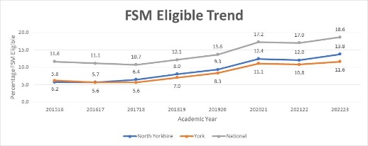

**Free school meals** Pupils eligible for free school meals:

2022/23: **11,449** in North Yorkshire / **2,991**  in York

2022/23: North Yorkshire 13.8% of pupils / York 11.6%

2016/17: North Yorkshire 5.78% of pupils / York 5.6%

**Measure of food insecurity** - Research has found that food insecurity is higher in the following groups: People with low incomes, particular those on benefits; Working age people (older people are less likely to report food insecurity); People in rented homes; Families with children; Minority ethnic groups and LGBTQ+; Disabled people and unpaid carers